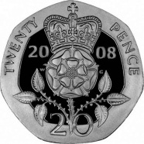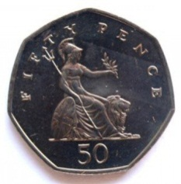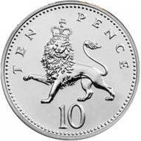C:\Users\Stephanie Bedford\AppData\Local\Microsoft\Windows\Temporary Internet Files\Content.IE5\BNPTSGNC\MC900285580[1].wmfC:\Users\Stephanie Bedford\AppData\Local\Microsoft\Windows\Temporary Internet Files\Content.IE5\ARL83NP7\MC900232725[1].wmfC:\Users\Stephanie Bedford\AppData\Local\Microsoft\Windows\Temporary Internet Files\Content.IE5\ARL83NP7\MC900036398[1].wmfC:\Users\Stephanie Bedford\AppData\Local\Microsoft\Windows\Temporary Internet Files\Content.IE5\VIBORZSI\MC900413538[1].wmfC:\Users\Stephanie Bedford\AppData\Local\Microsoft\Windows\Temporary Internet Files\Content.IE5\VIBORZSI\MC900012984[1].wmfC:\Users\Stephanie Bedford\AppData\Local\Microsoft\Windows\Temporary Internet Files\Content.IE5\BNPTSGNC\MC900237670[1].wmfC:\Users\Stephanie Bedford\AppData\Local\Microsoft\Windows\Temporary Internet Files\Content.IE5\ARL83NP7\MC900064977[1].wmfC:\Users\Stephanie Bedford\AppData\Local\Microsoft\Windows\Temporary Internet Files\Content.IE5\ZU6FXWJN\MC900287297[1].wmfC:\Users\Stephanie Bedford\AppData\Local\Microsoft\Windows\Temporary Internet Files\Content.IE5\ARL83NP7\MC900013282[1].wmfC:\Users\Stephanie Bedford\AppData\Local\Microsoft\Windows\Temporary Internet Files\Content.IE5\ARL83NP7\MC900013282[1].wmfC:\Users\Stephanie Bedford\AppData\Local\Microsoft\Windows\Temporary Internet Files\Content.IE5\ARL83NP7\MC900013282[1].wmfC:\Users\Stephanie Bedford\AppData\Local\Microsoft\Windows\Temporary Internet Files\Content.IE5\ARL83NP7\MC900013282[1].wmfC:\Users\Stephanie Bedford\AppData\Local\Microsoft\Windows\Temporary Internet Files\Content.IE5\ARL83NP7\MC900013282[1].wmfC:\Users\Stephanie Bedford\AppData\Local\Microsoft\Windows\Temporary Internet Files\Content.IE5\ARL83NP7\MC900013282[1].wmfC:\Users\Stephanie Bedford\AppData\Local\Microsoft\Windows\Temporary Internet Files\Content.IE5\ARL83NP7\MC900013282[1].wmfC:\Users\Stephanie Bedford\AppData\Local\Microsoft\Windows\Temporary Internet Files\Content.IE5\ARL83NP7\MC900013282[1].wmf

**Is it**

**Can you find the right coin for the shop keeper?**

**50p**

**20p**

**10p**

**50p**

**20p**

**10p**

**50p**

**50p**

**20p**

**20p**

**10p**

