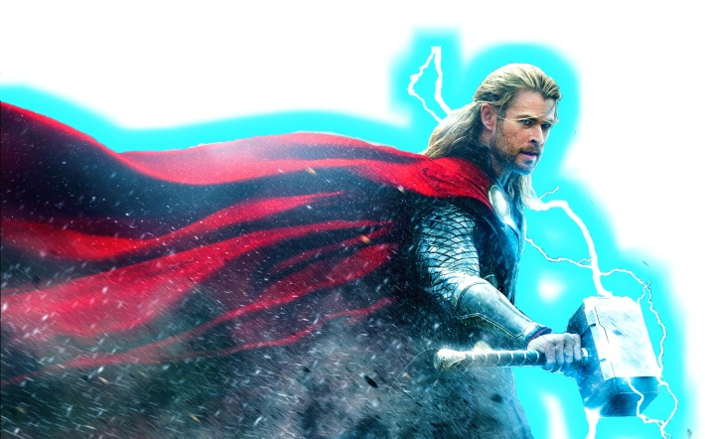  8 x 11 = |  | 7 x 6 = | Batman and Hawk-girl are defeated! Have you practiced your 6, 7 and 8 times tables enough to vanquish the terrible Thor? | 5 x 2 =
6 x 7 = |  | 6 x 12 = |  | 2 x 3 =
8 x 2 = |  | 8 x 4 = |  | 1 x 4 =
6 x 1 = |  | 6 x 3 = |  | 4 x 5 =
7 x 7 = |  | 7 x 4 = |  | 3 x 7 =
6 x 6 = |  | 6 x 11 = |  | 10 x 9 =
8 x 3 = |  | 7 x 9 = |  | 0 x 10 =
6 x 8 = |  | 8 x 10 = |  | 9 x 2 =
7 x 5 = |  | 7 x 1 = |  | 5 x 3 =
6 x 2 = |  | 6 x 9 = |  | 8 x 4 =
8 x 6 = |  | 7 x 8 = |  | 3 x 5 =
6 x 10 = |  | 8 x 8 = |  | 6 x 6 =
7 x 0 = |  | 7 x 3 = |  | 4 x 7 =
6 x 0 = |  | 8 x 1 = |  | 60 ÷ 10 =
7 x 2 = |  | 7 x 11 = |  | 56 ÷ 7 =
8 x 5 = |  | 6 x 4 = |  | 49 ÷ 7 =
6 x 5 = |  | 8 x 7 = |  | 72 ÷ 6 =
7 x 10 = |  | 7 x 12 = |  | 64 ÷ 8 =
8 x 12 = |  | 8 x 9 = |  | 48 ÷ 8 =
8 x 0 = |  | 2x10 = |  | 24 ÷ 6 =

Thor is amazed that you are so fast! He tries to use some word problems to distract you…
1. 6 cats have 4 kittens each. How many kittens are there in total?
2. I have 66 cookies and can fit 6 cookies into a box. How many boxes will I need?
3. In a school there are 96 children. There are 8 classrooms. How many children in each class?
4. Mrs. Emma picks 3 flowers a day starting on Monday. How many does she have by Sunday?
5. There are 7 windows on a house. How many windows on 8 houses?

Your time
Time needed to beat Thor | 3 minutes 50 seconds

