Spiderman

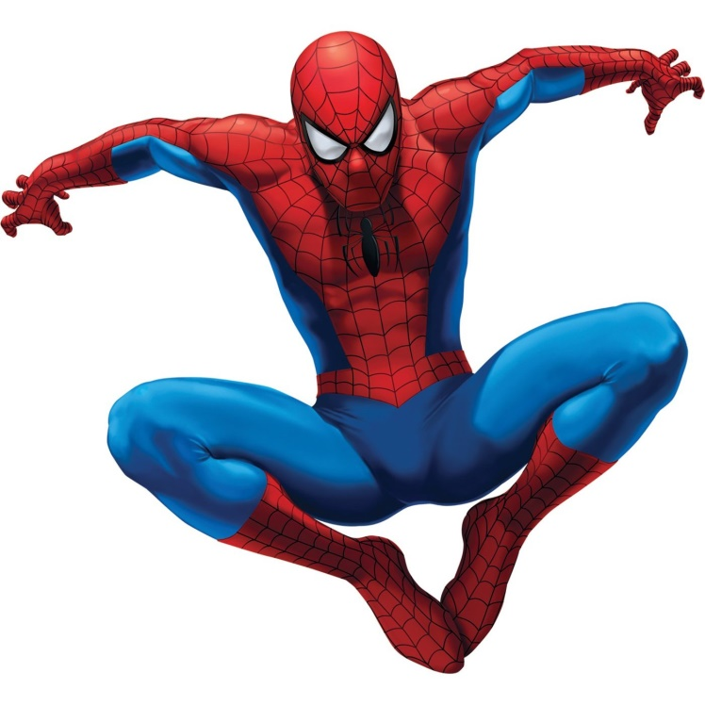
Orphaned as a baby, Peter Parker was raised by his elderly Uncle Ben and Aunt May. Academically gifted, Peter was a natural when it came to science, some say he was a nerd, others say he was a genius. Socially however, he was not, he was painfully shy and always the butt of everyone’s jokes at Midtown High School. During a school trip to the local Science Museum, he was bitten on the hand by a radioactive spider, empowering Peter with the arachnid's strength, agility and the ability to cling to almost any surface. Peter knew that with great power comes great responsibility, he had to use his new powers to help and protect the weak, vulnerable and the helpless citizens of New York City. Peter decided that he had to disguise himself, so that his enemies would not be able to recognise him and hurt the ones he loved. The first enemy he had to face was the menacing green goblin, however over the years Spiderman faced many enemies, such as the villainous Dr Octopus and the terrifying Venom.

Questions
- Who raised Peter after his parents passed away?
- What was the name of school Peter attended?
- Where was Peter when he was bitten by the spider?
- The word ‘arachnid’ is a scientific word for what?
- Explain what is meant by the phrase ‘Academically gifted’
- What 3 words were used to describe Peter’s characteristics?
- What powers did Peter gain from the spider bite?
- Why did Peter decide to disguise himself?
- What 3 words were used to describe some of Spiderman’s enemies?
- Write a sentence using at least 2 adjectives to describe what you think of Spiderman.

