**Write the coins you will need in the boxes!**

**Correct Change Please!**

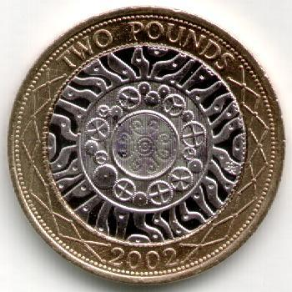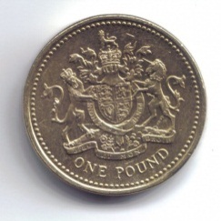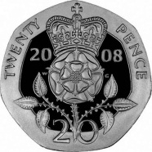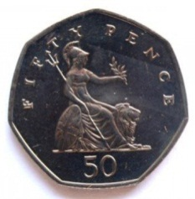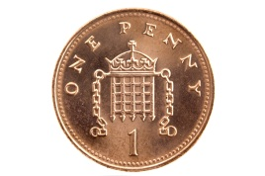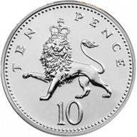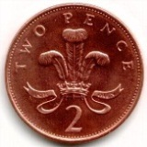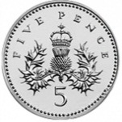

**£1**

**£2**

**20p**

**50p**

**10p**

**1p**

**2p**

**5p**





**8p**

C:\Users\Stephanie Bedford\AppData\Local\Microsoft\Windows\Temporary Internet Files\Content.IE5\4ALTZ25C\MC900215937[1].wmfC:\Users\Stephanie Bedford\AppData\Local\Microsoft\Windows\Temporary Internet Files\Content.IE5\8AILHBE5\MC900113370[1].wmfC:\Users\Stephanie Bedford\AppData\Local\Microsoft\Windows\Temporary Internet Files\Content.IE5\N379WE45\MC900234010[1].wmf



**52p**



**15p**



**60p**