**Write the coins you will need in the boxes!**

**Correct Change Please!**

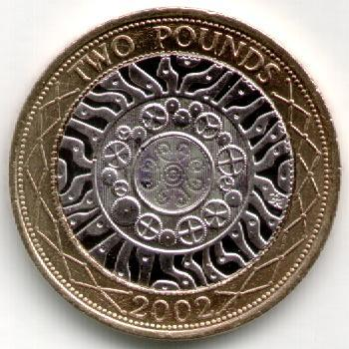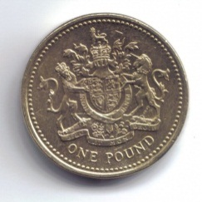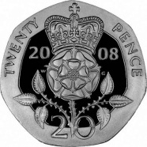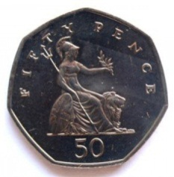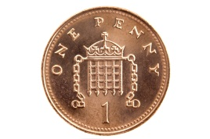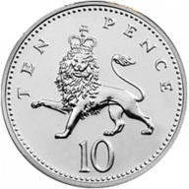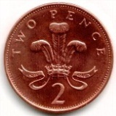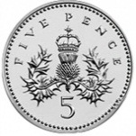

**£1**

**£2**

**20p**

**50p**

**10p**

**1p**

**2p**

**5p**





**80p**

C:\Users\Stephanie Bedford\AppData\Local\Microsoft\Windows\Temporary Internet Files\Content.IE5\VLRZCBO6\MC900301512[1].wmfC:\Users\Stephanie Bedford\AppData\Local\Microsoft\Windows\Temporary Internet Files\Content.IE5\8AILHBE5\MC900389384[1].wmfC:\Users\Stephanie Bedford\AppData\Local\Microsoft\Windows\Temporary Internet Files\Content.IE5\VLRZCBO6\MC900281692[1].wmfC:\Users\Stephanie Bedford\AppData\Local\Microsoft\Windows\Temporary Internet Files\Content.IE5\ARL83NP7\MC900013282[1].wmfC:\Users\Stephanie Bedford\AppData\Local\Microsoft\Windows\Temporary Internet Files\Content.IE5\ARL83NP7\MC900013282[1].wmfC:\Users\Stephanie Bedford\AppData\Local\Microsoft\Windows\Temporary Internet Files\Content.IE5\ARL83NP7\MC900013282[1].wmf

**£1.50**

**£2.05**

**£1.25**