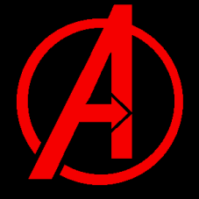
The Avengers is a team of superheroes that are found in Marvel Comics. Labelled Earth’s mightiest heroes, the Avengers originally consisted of Iron Man, Ant-Man, The Wasp, Thor, The Hulk and Captain America.
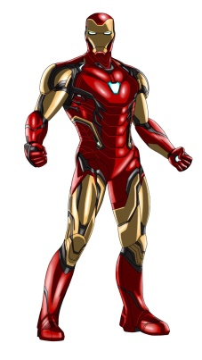
Iron Man is an American billionaire called Tony Stark. He was kidnapped and suffered a serious chest injury. Instead of building a weapon of mass destruction, he built a powered suit of armour to save his life.

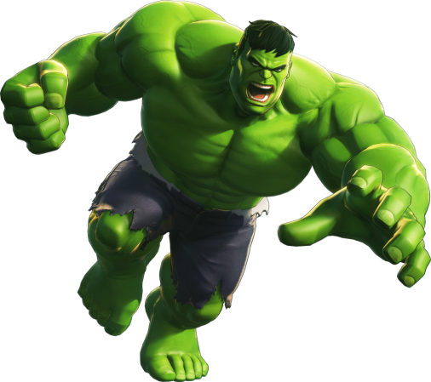
Dr. Bruce Banner was transformed into the incredibly powerful creature called the Hulk. When he suffers emotional stress, he changes into a large green humanoid that possesses superhuman strength and great invulnerability. These powers grow stronger the angrier he becomes. The Hulk can slam his hands together creating a shock wave, which can deafen people, send objects flying and extinguish fire. His thunderclap has been compared to hurricanes and sonic booms. The Hulk uses his superhumanly strong leg muscles to leap to great distances and can cover hundreds of miles in a single bound. The Hulk can also use his superhumanly leg muscles to run at super speeds, although his legs have limitless speed and once he reaches a certain speed his legs becomes too strong and destroy the ground, therefore he jumps to travel.

Real name Janet Van Dyne, the wasp has the ability to change from the size of a wasp to a giant. She flies with insectoid wings and fires yellow energy blasts.
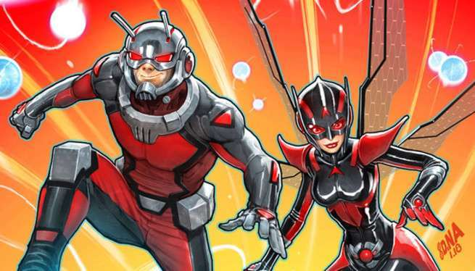
Henry ‘Hank’ Pym became the superhero Ant-Man after discovering a chemical substance that would change his size. Armed with a helmet that could control ants, he would shrink down to the size of an ant to become the mystery-solving Ant-Man. His girlfriend and crime-fighting partner is the wasp.

Captain America is the alter ego of Steve Rogers, a frail young man. He took an experimental serum, so he could help the American government win World War 2. He carries an indestructible shield that he uses for defence and as a weapon.
Thor is the god of thunder and can control the weather with is hammer. Thor has super-strength, super-speed, invulnerability and the ability to fly.
Questions
- Who are the Avengers? Write down two things about them.
- Which word in the paragraph about Iron Man means demolition?
- What causes Dr Bruce Banner to transform into the Hulk?
- Write down two things that the Hulk can use the shockwave for.
- Which superhero is Henry ‘Hank’ Pym?
- Write down 2 tings that Ant Man can do when he wears a helmet.
- What does Thor use to control the weather?
- Which 3 nouns has the author chose to show Thor’s superpowers?
- Who fires yellow energy blasts?
- Make a bank of powerful superhero words that you could use to write your comic.

