Complete the questions by crossing out the wrong word

- Electricity can flow through the components in a complete/incomplete electrical circuit.

- A circuit always needs a power source/switch, such as a battery, with wires connected to both the positive (+) and negative (-) ends.

- A circuit can also contain other electrical components, such as bulbs/kettle, buzzers/bananas or motors/microwave, which allow electricity to pass through.

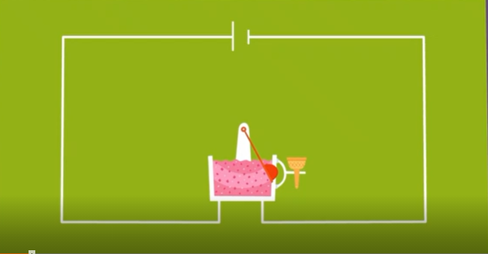
- Can you correct this circuit by adding a switch?

Draw the switch onto the diagram.

- Explain why it is important to have a switch on an electrical item, for example an ice cream machine. Is there a safety reason?

________________________________________________________________________________________________________________________________________________________________________________________________________________________________________________

