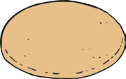
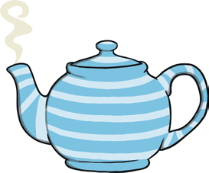
Help Snow White work out if she has got everything she needs for her tea party. Complete the tally chart to show what she already has.
Tally Chart
Item | Tally | Total
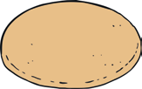

Now put your data into a pictogram.
In your pictogram, one picture should represent each object.

cupcakes | biscuits | cups and saucers | teapots | fruit scones

Answer these questions using your tally chart and pictogram.
- What does Snow White have the most of?

- Which does she have the least of?

- How many more biscuits are there than cupcakes?

- What is the difference between the number of fruit scones and the number of cupcakes?

- How many fruit scones and biscuits are there altogether?

- How many items are there to eat, altogether?

