Help Snow White work out if she has got everything she needs for her tea party. Complete the tally chart to show what she already has.

|  |  |  |
| --- | --- | --- |
| **Tally Chart** | | |
| Item | Tally | Total |
|  |  |  |
|  |  |  |
|  |  |  |
|  |  |  |
|  |  |  |

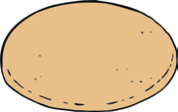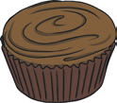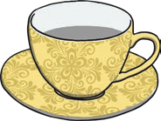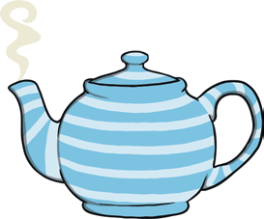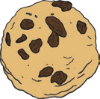

Now put your data into a pictogram.

In your pictogram, one picture should represent each object.

|  |  |  |  |  |
| --- | --- | --- | --- | --- |
|  |  |  |  |  |
|  |  |  |  |  |
|  |  |  |  |  |
|  |  |  |  |  |
|  |  |  |  |  |
| cupcakes | biscuits | cups and saucers | teapots | fruit scones |