Tuesday 21st April 2020
WALT – write expanded noun phrases

Choose 8 characters you can see in the ‘Where’s Wally?’ picture and write an expanded noun phrase to describe them. Write the sentences into your book or type them onto this sheet and print it.
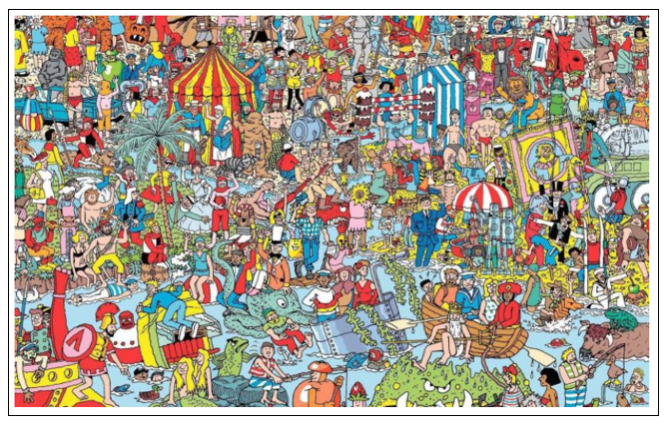
Can someone in your house find your character?

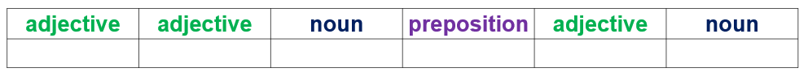
Use this writing frame to help you write the expanded noun phrases.
For example – elderly, bearded man with a golden crown

Type your answers below.

