How to make a cloud in a jar using hairspray
For this method, you will need the following materials:
- A jar with lid
- About 1/3 cup hot water
- Ice
- Hairspray (which I forgot to include in the picture below)
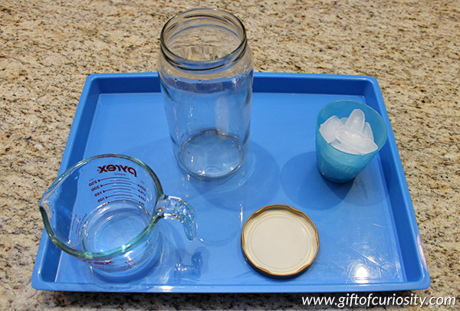
Start by pouring the hot water into the jar. Swirl it around a bit to warm up the sides of the jar.
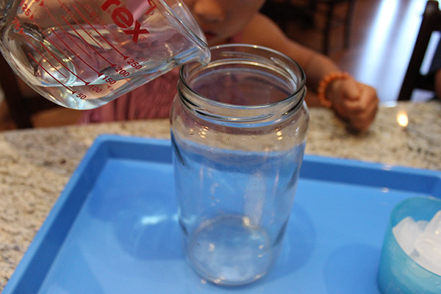
Turn the lid upside down and place it on the top of the jar. Place several ice cubes onto the lid, and allow it to rest on the top of the jar for about 20 seconds.
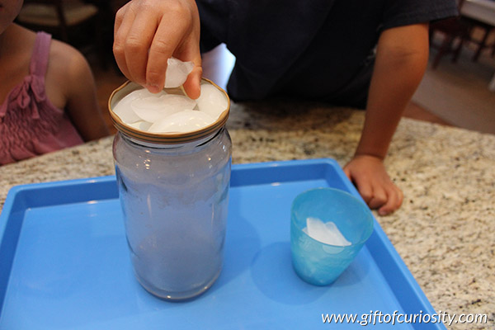
Remove the lid, quickly spray a bit of hairspray into the jar, and then replace the lid with the ice still on top. Watch the cloud form.
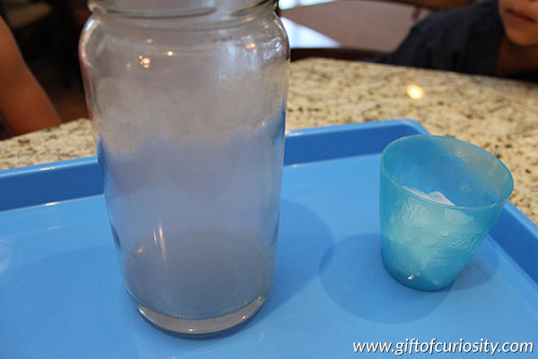
When you see a good amount of condensation form, remove the lid and watch the “cloud” escape into the air.
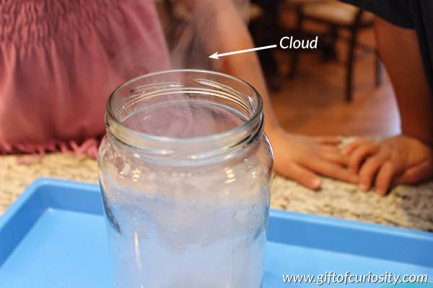

How does it work?
When you add the warm water to the jar, some of it turns to water vapor. The water vapor rises to the top of the jar where it comes into contact with cold air, thanks to the ice cubes on top. Water vapor condenses when it cools down. However, a cloud can only form if the water vapor has something to condense on to. In nature, water vapor may condense onto dust particles, air pollution, pollen, volcanic ash, etc. In the case of this activity, the water vapor condensed onto the hairspray.

