Can you spot the 2D shapes on the 3D shapes?
Name of 3D shape

2D shape I can see
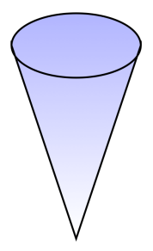 | Name of 3D shape  2D shape I can see
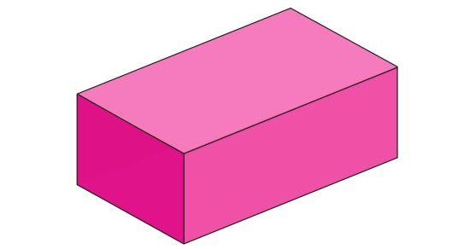 | Name of 3D shape  2D shape I can see
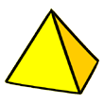 | Name of 3D shape  2D shapes I can see
Name of 3D shape

2D shape I can see
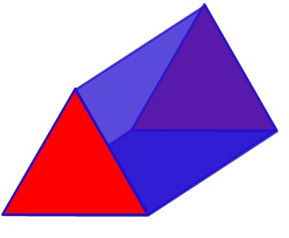 | Name of 3D shape  2D shapes I can see

