
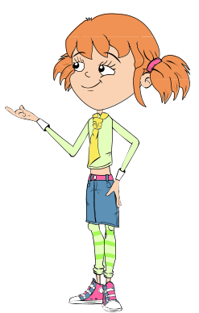
Bad
Bug
Challenge!

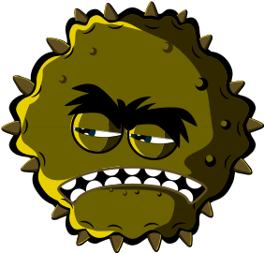



Can you find all the words associated with Bad Bugs in the word search below? Remember that the words can be horizontal (across), vertical (down) or diagonal (top left to bottom right).
COUGHHAYFEVERATHLETES FOOT COLD
ASTHMASleepy FOOD POISONING SPOT
MEASLES DIRTY HANDSFLUVOMIT HEADACHE INFLUENZA

SW 1
HARM
F | C | E | A | R | T | M | Y | Y | U | A | N | S | D | F
F | O | M | G | B | F | L | U | M | B | H | N | H | J | K
Z | L | O | N | Z | R | W | K | A | Y | E | A | E | A | L
F | D | S | D | H | G | D | A | S | T | H | M | A | T | A
V | B | H | N | P | H | N | J | O | H | D | D | D | G | T
S | V | V | A | C | O | U | G | H | N | C | I | A | B | H
M | S | O | S | X | J | I | D | F | B | G | R | C | G | L
E | T | G | M | Z | U | N | S | A | M | A | T | H | A | E
A | N | M | D | I | A | R | H | O | E | A | Y | E | J | T
S | Z | X | C | V | T | B | G | T | N | D | H | J | H | E
L | R | T | A | Y | U | N | I | A | O | I | A | F | G | S
E | Q | W | E | R | I | N | F | L | U | E | N | Z | A | F
S | P | O | T | I | O | P | L | B | K | J | D | G | G | O
A | S | D | M | S | L | E | E | P | Y | E | S | S | F | O
H | A | Y | F | E | V | E | R | N | F | G | N | H | K | T

