
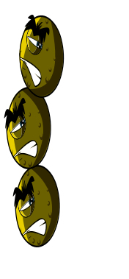



ACROSS
I make you do this when you have a cold to spread microbes by causing a tickle in your throat.
I am a viral disease that can give you swollen itchy red spots all over your body.
I am a part of your body and spread microbes from person to person. Washing me gets rid of bad microbes (2 words).
I am a viral disease that will make you hot and sweaty.
You will get me if you don’t cook your meat properly or wash your hands after handling raw meat (2 words).
I am a disease of the lungs, not caused by microbes. I make you so short of breath that you need to use an inhaler!
I am another word for a pain in your head.
DOWN
I make your eyes swollen and itchy. I am not caused by a microbe.
I am caused by flower pollen.
How you feel when your body is fighting infection.
I am a fungal infection of your feet. I make your toes itchy. I spread if you don’t wash and dry your feet well! (2 words).
I am often seen on teenager’s faces. I am sometimes caused by microbes on the skin.
Bad microbes in your tummy can sometimes cause this. If you don’t wash your hands after going to the toilet it can spread around your school.
Watch out! Bad tummy microbes can sometimes take you by surprise and make you do this.
ANSWERS
influenzahayfevermeasles headache diarrhoea
asthma athletes foot vomit spot cough
sleepydirty hands food poisoning
SW 2
HARM
 | ¹ |  |  |  | ²
 | ³
⁴
 |  |  |  |  |  |  |  | ⁵
 |  |  | ⁶
 |  |  | ⁷
 |  | ⁸
 | ⁹ |  |  | ¹⁰
 |  |  |  |  |  |  |  |  |  | ¹¹
 |  |  |  |  |  | ¹²
 |  | ¹³

