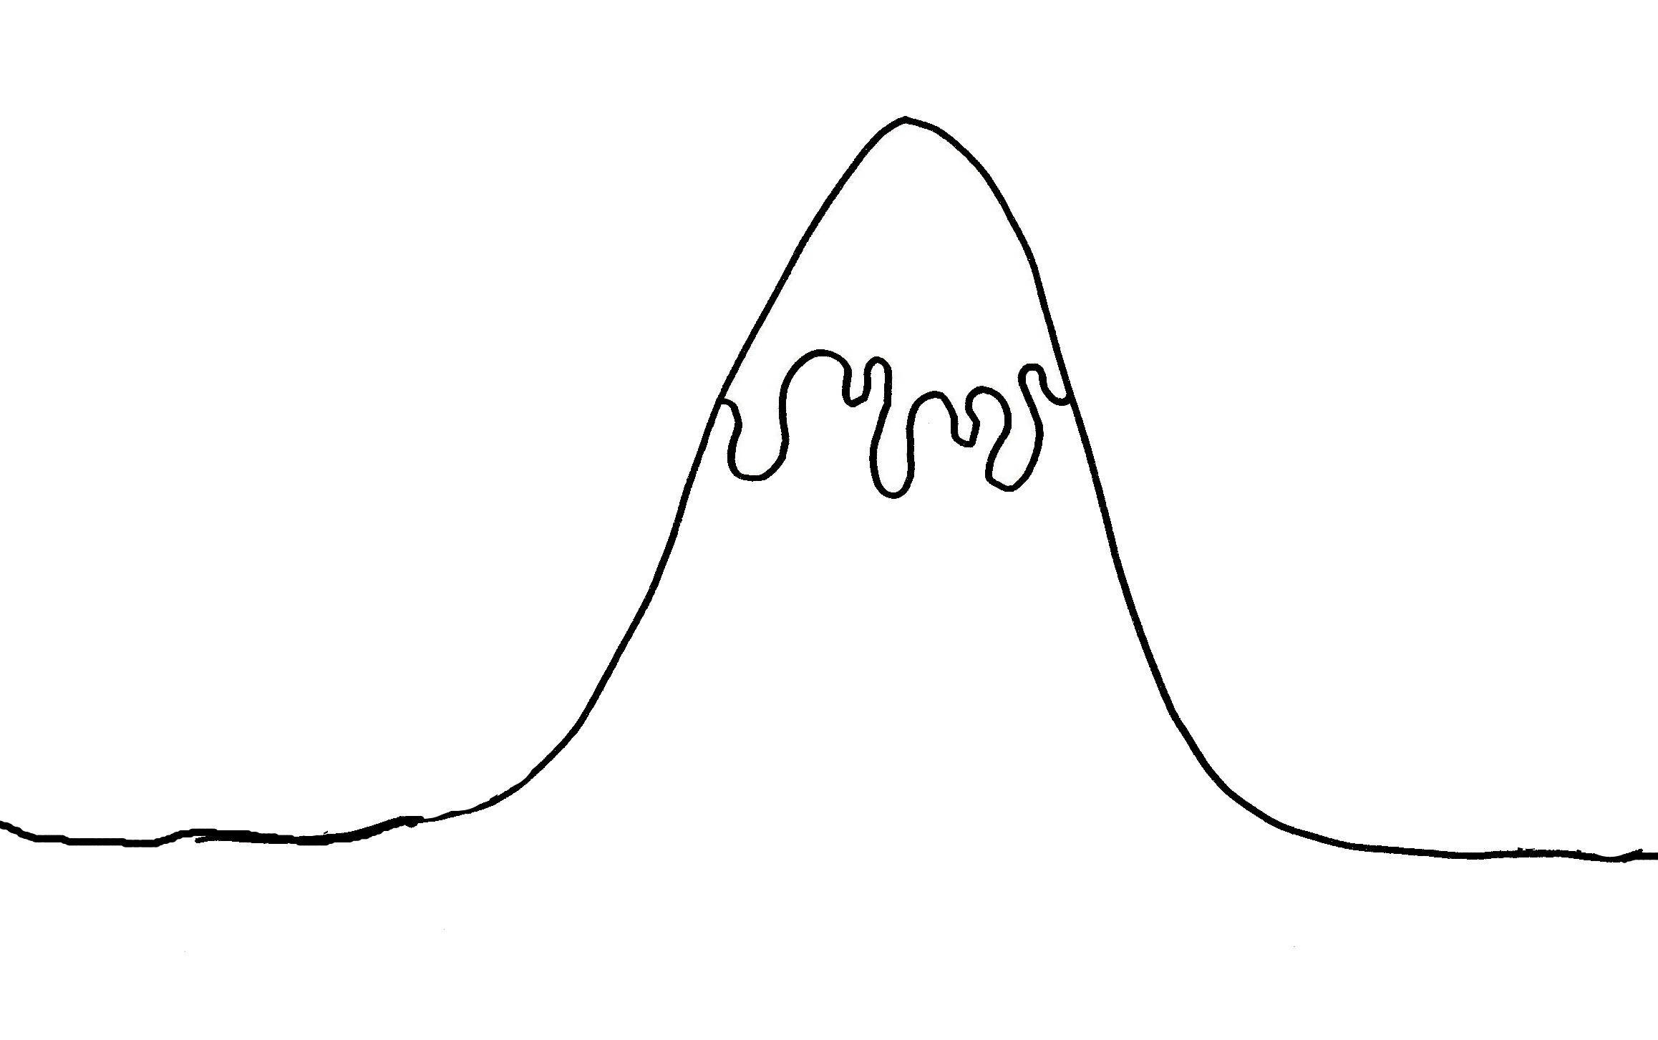

**Fix problem**

____________________________________________________________________________________________________________________________________________________________________________________________________________

**Problem!!**

______________________________________________________________________________________________________________________________

**Ending**

______________________________________________________________________________________________________

**Build up**

____________________________________________________________________________________________________________________________________________

**Introduction**

Who: ________________________________________________

Where______________________________________________________________________________________________________

_-

**The Story Mountain**

**The Story Mountain**