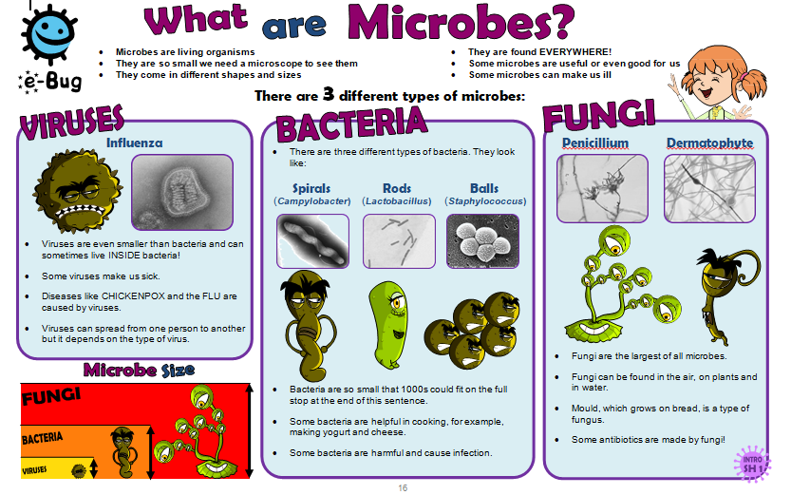

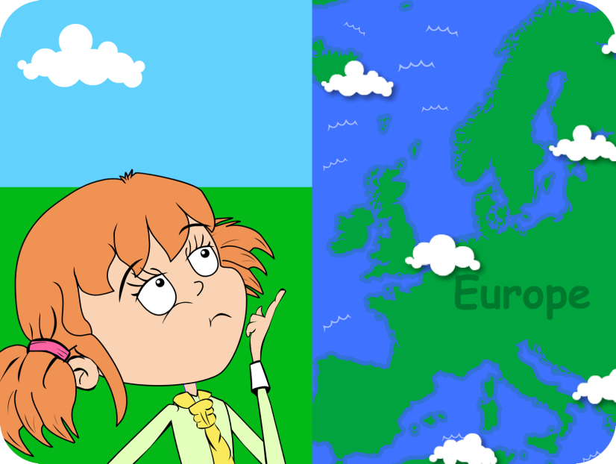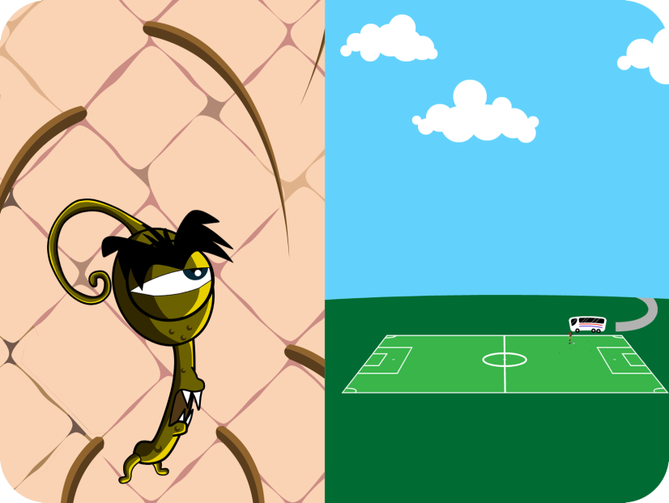C:\Documents and Settings\Sandy\Desktop\eBug\Logo\Final Logo\Final Logo.emf

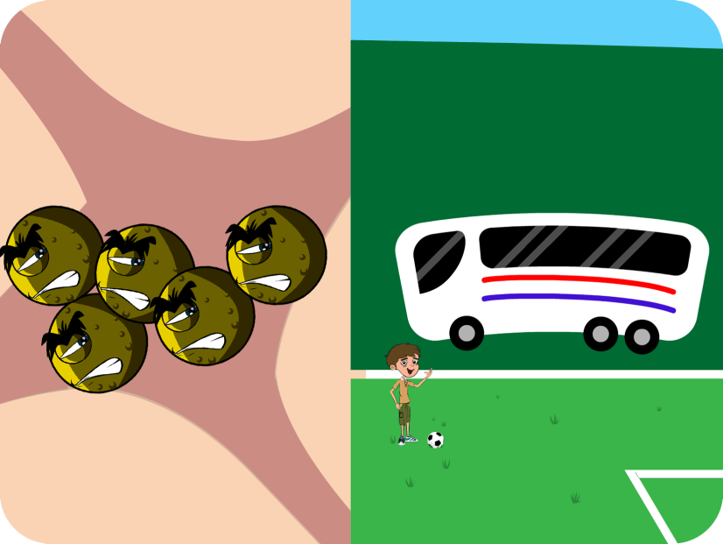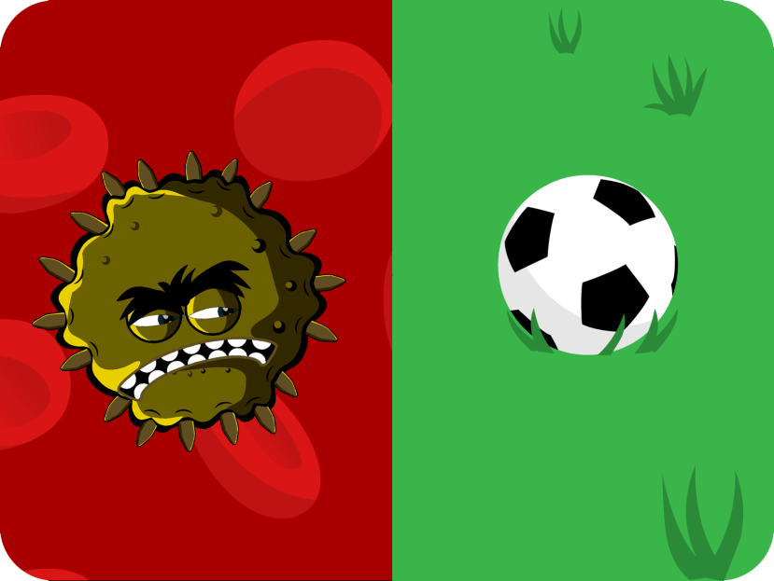Harry_009



**3. A BACTERIUM would be the size of a BUS!**

**1. If you were as big as EUROPE...**

**4. A VIRUS would be the size of a FOOTBALL!**

**2. A FUNGUS would be the size of a football pitch!**

C:\Documents and Settings\Sandy\Desktop\eBug\Logo\Final Logo\Final Logo.emf

123

Make your own Microbe

Design a microbe of your choice, either a bacterium, a virus or a fungus   
using the materials provided.

Before you start, decide if your microbe will be beneficial or harmful! Here are some pictures which might help!

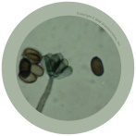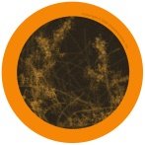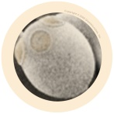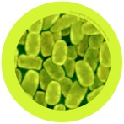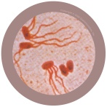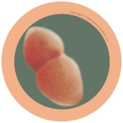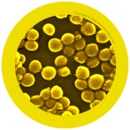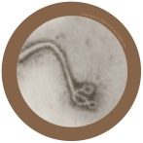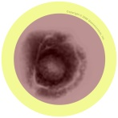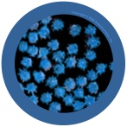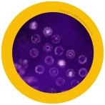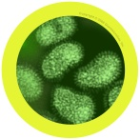glass2PencilPenicillium_01influenza_01Lactobacillus_01

**This is a picture of my** \_\_\_\_\_\_\_\_\_\_\_\_\_\_\_\_\_\_\_\_\_\_\_\_\_



Fungi

Bacteria

Viruses

**Top Tip**

Bacteria come in lots of different shapes and sizes – some are round like balls, some are like spirals and some are long like rods. Some even use tail like structures to help them swim and move!

**Fascinating Fact**

**YOU are home to 1000 million microbes!**

1. Is it a beneficial or harmful microbe?

\_\_\_\_\_\_\_\_\_\_\_\_\_\_\_\_\_\_\_\_\_\_

1. Choose a name for your microbe.

\_\_\_\_\_\_\_\_\_\_\_\_\_\_\_\_\_\_\_\_\_\_

Lactobacillus_01C:\Documents and Settings\Sandy\Desktop\eBug\Logo\Final Logo\Final Logo.emf

I’m called a ***Dermatophyte*** and I like to live on your skin. I especially like living in damp places like between the toes on sweaty feet! When I live there I give people athlete’s foot! What am I?

Dermatophytes are:

\_\_\_\_\_\_\_\_\_\_\_

My name is ***Lactobacillus***. People call me ‘friendly’ because I change milk into yogurt! When you eat me in yogurt I live in your guts and help you digest other food. What am I?

*Lactobacillus* is a:

\_\_\_\_\_\_\_\_\_\_\_

My name is ***Staphylococcus***. I am round in shape and I like to live in your nose or armpit! If I live on your skin I can give you spots. If I get into your bloodstream I can make you ill! What am I?

*Staphylococcus* is a:

\_\_\_\_\_\_\_\_\_\_\_

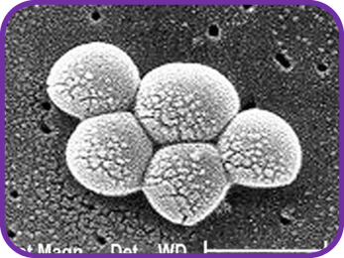Staphylococcus_01

Dermatophyte_01

123

There are 3 different types of microbe – bacteria, viruses and fungi.

From the pictures and descriptions, can you work out which microbe is which?

**Hint**

Remember there are three different types of bacteria

* rods
* spirals
* balls

Campylobacter_01Penicillium_01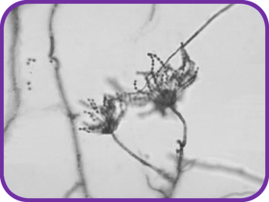influenza_01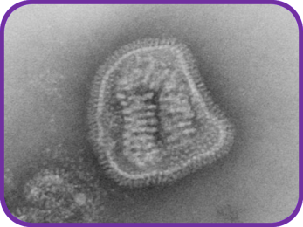



My name is ***Campylobacter***. I have a pretty spiral shape and I like to live in chickens but if I get into your tummy I make you very ill – I can give you diarrhoea! What am I?

*Campylobacter* is a:

\_\_\_\_\_\_\_\_\_\_\_

My name is ***Penicillium*** and you’ll find me growing on old oranges or stale bread making them look mouldy. Humans use me to make an antibiotic called Penicillin which can make them better, but only from bacterial infections! What am I?

*Penicillium* is a:

\_\_\_\_\_\_\_\_\_\_\_

My name is ***Influenza*** but my friends call me the ‘flu’. I’m very generous; I like to give people headaches and fever. I easily spread from person to person through coughing and sneezing. What am I?

*Influenza* is a:

\_\_\_\_\_\_\_\_\_\_\_