Time to Think!
Write the answer to each question and draw the correct time on the clock.

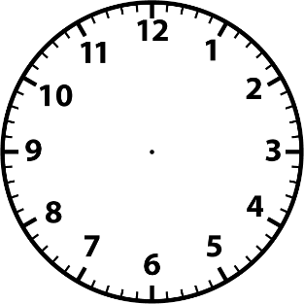
- At 5:30, Harry started drinking his tea. It took him 30 minutes. What time did he finish?

He finished at _____: _________

- At 2:00, Mary went for a walk with her friend for one hour. What time did Mary finish her walk?

She finished at _____: _________

- Playtime starts in 30 minutes. It is 4:30 right now. What time will playtime starts?

Playtime starts at _____: _________

- Mary went shopping at 4:30 for 2 hours. When did Mary finish shopping?

Mary finished shopping at _____: _________
Clock Faces © bcpss.org
Time to Match!
Match the times to the correct clock
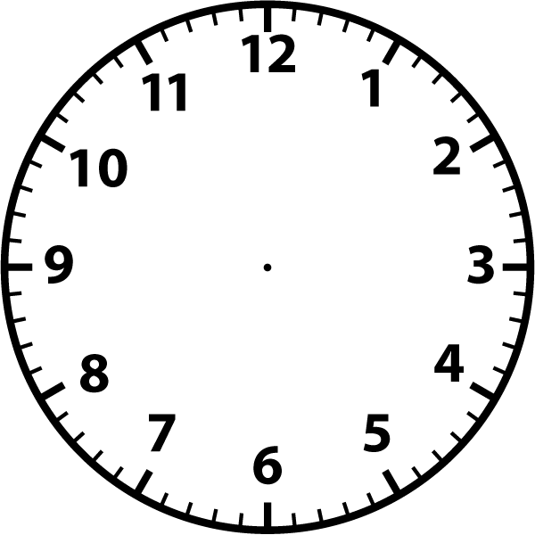
Clock Faces © bcpss.org
4:30
5:00
8:00
9:30
Time to get Working!
Draw the correct time in each of the clock faces
Clock Faces © bcpss.org
1:00
12:00
11:30
8:30
9:00
2:30
7:00
5:30
4:00
Time to Play!
Cut out the times at the bottom of the page and paste them under the correct clock face
Clock Faces © bcpss.org
12:30
8:30
10:00
5:00
2:00
4:00

