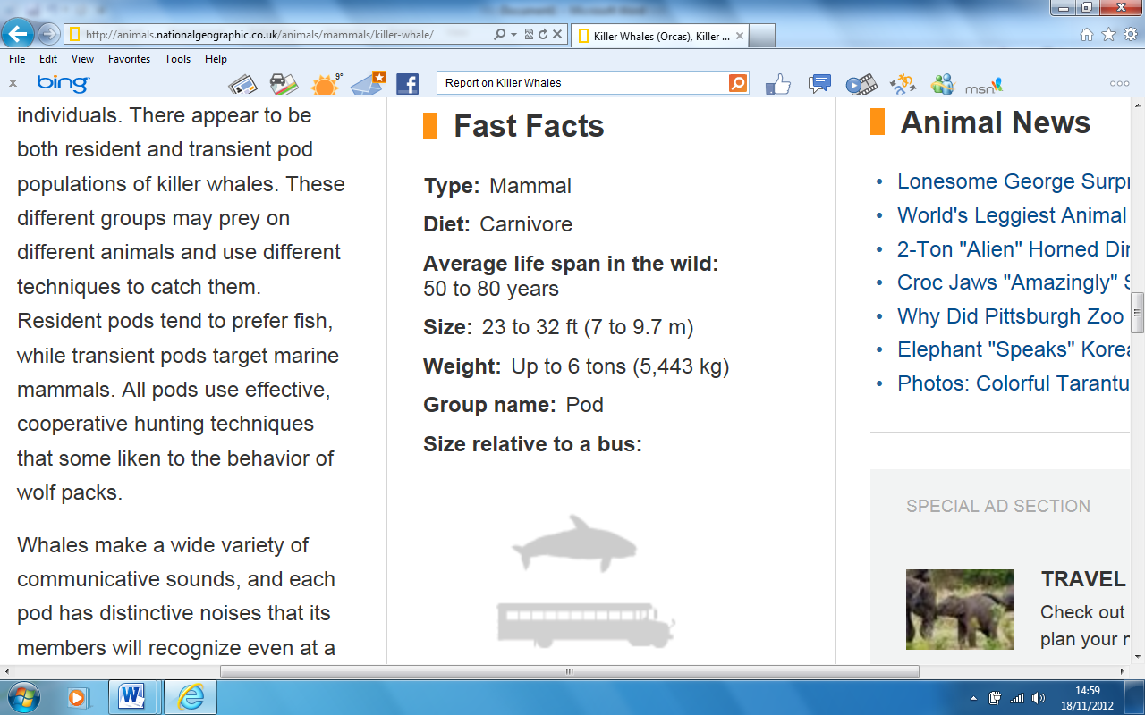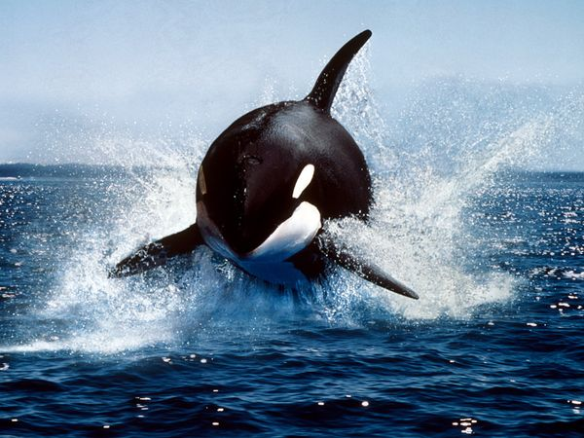

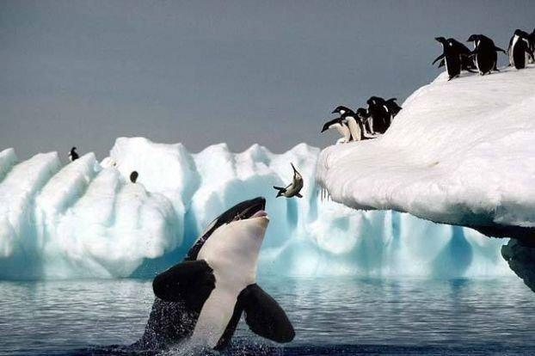

**Physical Characteristics**

Killer whales have black backs,white chests and sides, and white circles above and behind their eyes.

Male killer whales usually grow to an average of 20 - 26 feet and weigh an average of 8,000 lbs - 12,000 lbs while the female grows to an average of 16 - 23 feet and weighs between 3,000 lbs – 6,000 lbs.

The largest recorded whale measured in at 32 feet and weighed over 10 tons.

Killer whales have a single blow-hole, pectoral flippers, flukes and a dorsal fin.

Killer Whale Facts

The killer whale (orcinus orca) is part of the (odontoceti) toothed whale suborder. While the killer whale carries the name whale it is actually considered a dolphin.

In fact it is the largest of the dolphin species and has even been known on rare occasion to attack other whales.

Killer whales are one of the most well-recognized sea mammals and are easily spotted by their strong black and white colouring. They are extremely intelligent, well-organized and follow highly complex social structures within their pods often consisting of large groups of family members and is considered one of the most stable social structures of any of the animal species.

Having no known predators the killer whale is known as an apex or alpha predator, which is able to hunt freely without fear of being attacked by another animal.

Other than the name killer whale these whales are also referred to as the orca and black-fish.

**Killer Whales *(Ocra)***

Diet

Killer whales will feast on small aquatic lifeforms such as fish and squid and larger mammals like sea lions, seals and even other whales.

Depending on the region the whale lives in their diets can change dramatically.

Food intake can also vary significantly, eating anywhere from 2% to 10% of their body weight in food on a daily basis.

Calves (new-born whales) will tend to eat a high percentage of food compared to adult whales.

Some interesting animals and species found in the stomach of killer whales include:

■Birds

■Whales

■Reptiles

■Polar Bears

■Moose

**Social Structure**

The complexity of the social structure of killer whales can be compared to elephants and humans Killer whales hunt in pods (also known as groups) of up to 40 whales. As many as four generations of family members can be seen traveling within the pods.

They are very protective of their young and will attack if feel threatened.

Individual killer whales will leave their pods only for short periods of time (a few hours) to forage and mate. Killer whales usually hunt in groups and use complex hunting methods to attack and capture their prey.

