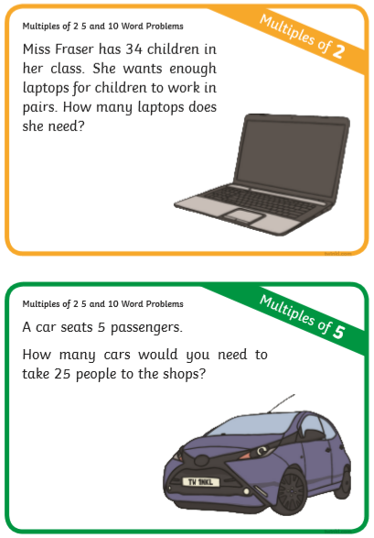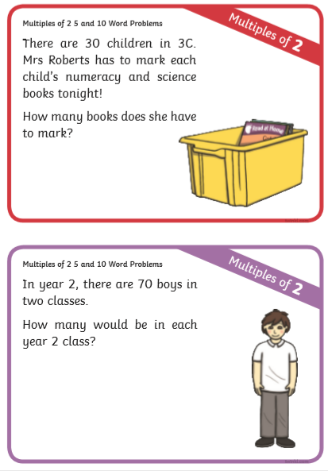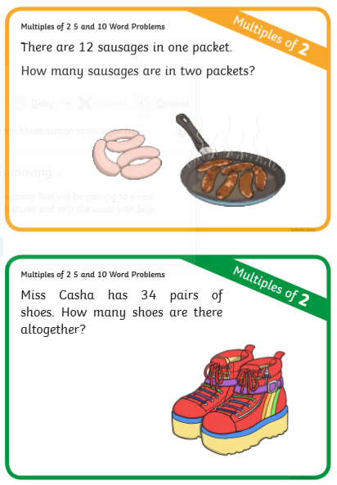

When you’re answering your question. Draw each set of 2 to show me how you have worked out your answer.

For example: There are 16 loose socks, how many will there be when we put them into pairs?

:::::::: =8pairs