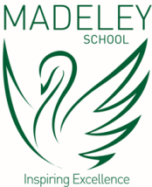

***Discover***

**Madeley School**

**PHENOMENAL GCSE RESULTS!**

**Our 2020 GCSE results are exceptional and yet again place Madeley School as one of the highest performing schools across Staffordshire, Cheshire, and the whole of the West Midlands.**

**Maths 90% 4+, 83% 5+ English 92% 4+, 72% 5+**

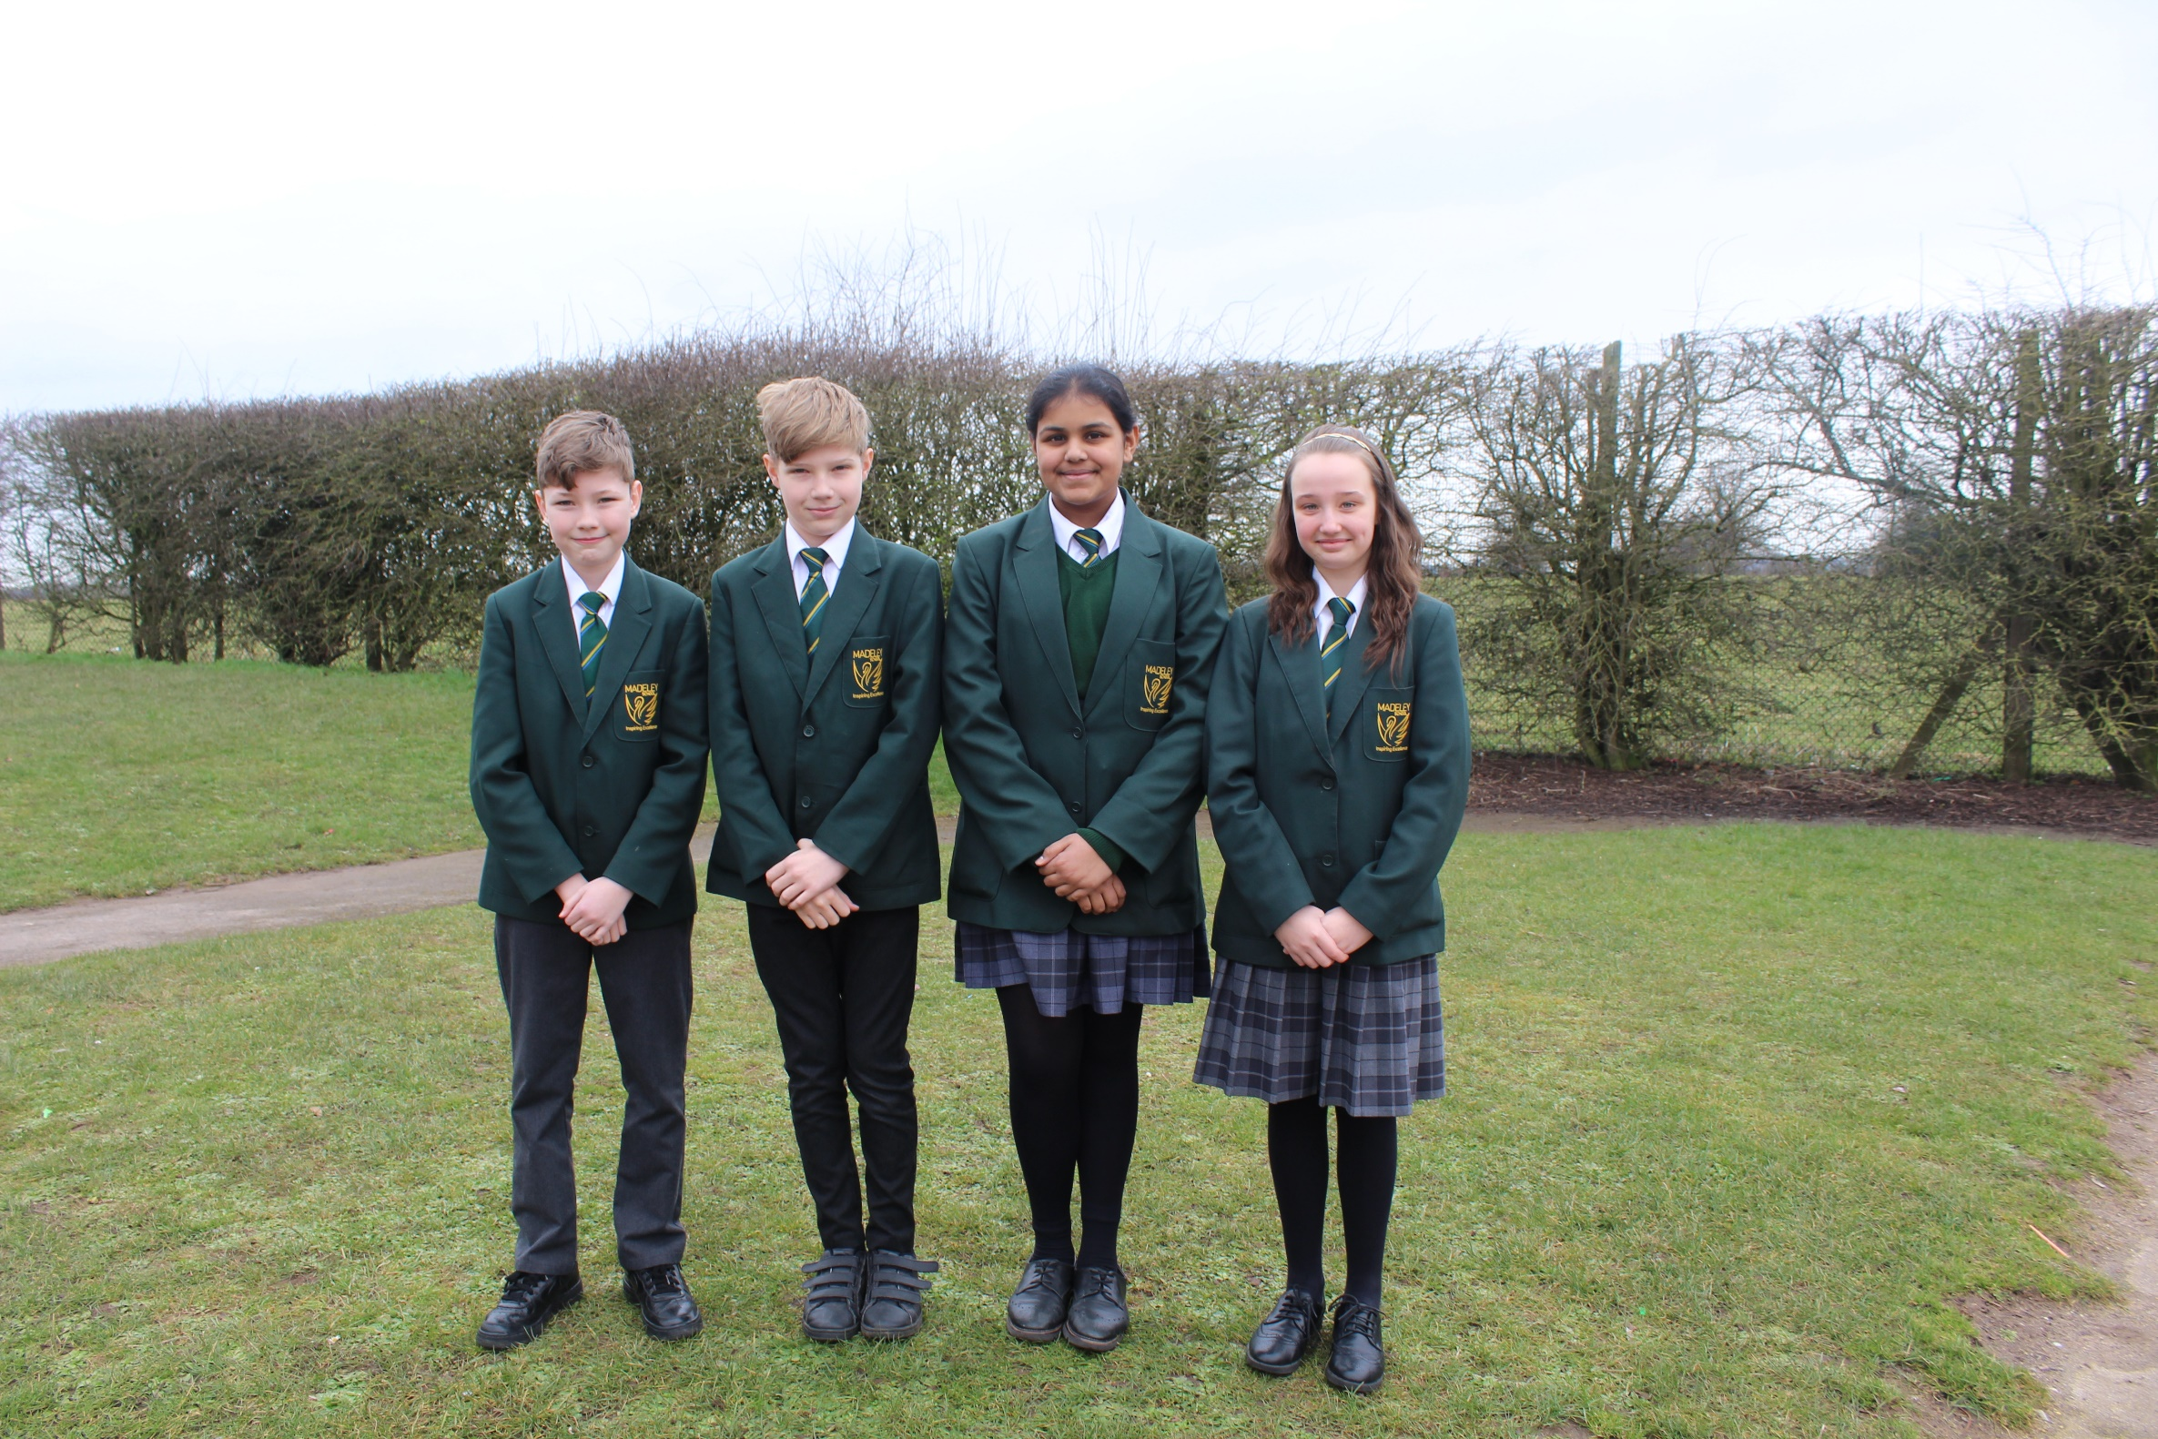

**VIRTUAL OPEN EVENTS**

**FOR PROSPECTIVE PARENTS**

**Including demonstrations, speeches, interviews and more**

**Activities commence from**

**Tuesday 6th October 2020**

