Village Nativity Hunt
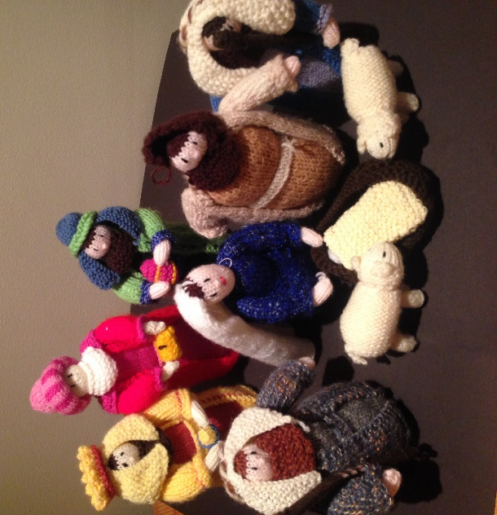
The week before Christmas (starting Friday 18th December) our knitted crib figures will be hiding round the village on window ledges. I wonder if you can find them?

- Mary, Joseph and the donkey
- 1 angel
- 2 shepherds and 2 sheep
- 3 Kings
- And 1 baby Jesus
There will be a prize for those who find them all. Put your answers on the sheet below and bring them to church on Christmas Eve.

4.30pm Christmas Eve - OUTDOOR Carols around the crib.

Crib figure | Name/number of house and street where you spotted it
Angel

Mary

Joseph

Donkey

Sheep

Shepherd 1

Shepherd 2

King 1

King 2

King 3

Baby Jesus

