Learning Objective
We are learning how to write sentences about elephant seals in both the active and the passive voice.

Challenge
Write your own script for Sir David Attenborough style to accompany the elephant seal and king penguin clip. See if you can do this by following the instructions below:
Sentence 1: Your sentence must be in the active voice.
Sentence 2: Your sentence must include a simile.
Sentence 3: Your sentence must be written in the passive voice.
Sentence 4: Your sentence must include a relative clause.
Sentence 5: Your sentence must include at least 2 words from the Word Wall.
Sentence 6: Your sentence must be in the active voice.
Sentence 7: Your sentence must include an expanded noun phrase.
Sentence 8: Your sentence must be in the passive voice.
Sentence 9: Your sentence must include a question.

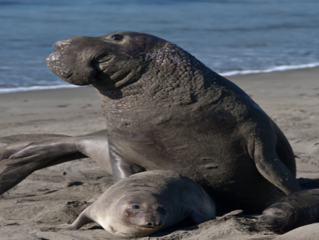
A relative clause can be used to give additional information about a noun.
They are introduced by a relative pronoun like 'that', 'which', 'who', 'whose', 'where' and 'when'.
For example:

‘The king penguins are scared when the elephant seals are fighting.’

Question to end with.

For example:
‘Will the king penguins be able to avoid this intense battle?’

Expanded noun phrases tell you more about the noun.
For Example:
‘The elephant seal’ would become ‘The gigantic, blubbery elephant seal’

A simile describes something by comparing it to something else, using like or as.
For Example:
'Their skin was tough as old boots.'

Word Wall
elephant seal
rival

barrier

slapped

sleeping giant

king penguin

blubbery beach master

waddled

crossfire

elephantine snout

