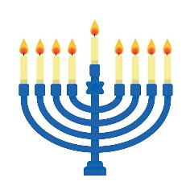
Hanukkah

Where do Jewish people go to worship?

Who leads the worship?

How many days does Hanukkah last for?

What is the name of the special candle holder that is lit every night?

Who were the Maccabees and what did they do?

How do Jewish people celebrate Hanukkah?

