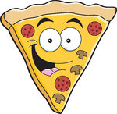
Week 1: Research

Where does pizza come from?

What is pizza made from?

What shapes and sizes are pizzas?

What sort of toppings can pizza have?

When do people eat pizza?

What toppings does your pizza have?
What sauce does your pizza have on it?
What type of bread and what shape is it?
Did you like the look of your pizza?
Did you enjoy the taste?
What would you change about the pizza?
Taste Test (Optional)

