Learning Objective
We can use the apostrophe to indicate possession with both singular and plural nouns.

Challenge 1
Add the apostrophes for possession to the correct places in the sentences.

- Interestingly, the bottle-nosed dolphins nose is short and stubby which gives them their name.
- The dolphins predators include killer whales and large sharks.
- A dolphins mother will stay with her baby (calf) until they are between three and six years old.
- The bottle-nosed dolphins hearing is amazingly powerful which enables them to communicate with each other over large distances.
- A bottle-nosed dolphins life expectancy can be up to forty years!

Challenge 2
Does the position of the apostrophe tell us that the sentence is talking about one or more dolphins? Underline the word with the apostrophe if you think it’s one dolphin or circle the word if you think it’s more.

- These dolphins’ tactic to hunt fish is very unique.

- The dolphins’ family groups are called a pod.

- A dolphin’s clicking noises means that it is communicating with its pod.

- Dolphins’ diets are mostly fish although they also eat shrimp and squid too.

- If a dolphin’s predator comes close, he or she can swim away at very fast speeds.

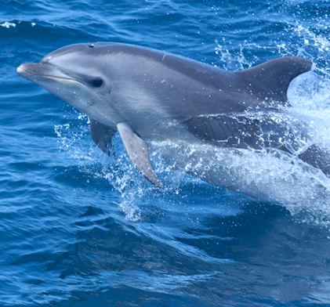
Word Wall
bottle-nosed dolphin
communicate
dangerous
muddy bank
synchronized
pod
sleek
bow wave
intelligent
beached
tactics
Challenge 3
Using some of the words on the Word Wall, write a short paragraph describing how the bottle-nosed dolphins use their unusual hunting techniques to catch fish. Think about how they need to work as a team. Can you include 3 apostrophes for possession in your writing? Try to include sentences that show possession with both singular (one) and plural (more than one) nouns.

