Learning Objective
We are learning how to write effective expanded noun phrases.

Writing Challenge
In centuries past, the ocean was thought to be full of krakens, sea serpents, sea monsters and mermaids. In fact, when Christopher Columbus set out to sea in 1492, he recorded what he thought was his own mermaid sighting; little did he know that this encounter was actually the first written record of manatees in North America!
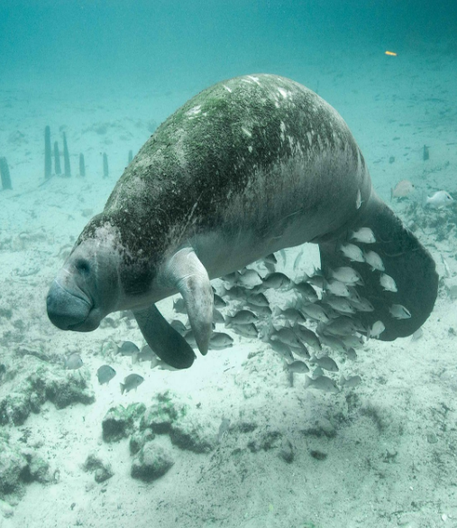
Writing as Columbus, record your thoughts and feelings about this encounter. Use the questions and the adjective list below to help you.
- What was the day like?
Adjective
List
- What did you see?
- What were you feeling?
knife-like
gentle
- Should you capture it or leave it alone?
sunshine
scarred
crystal-clear
powerful
shallow
paddle-shaped

