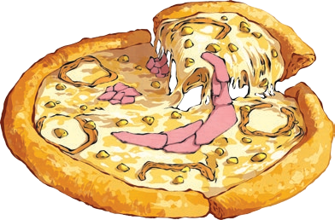
You are about to create your own ‘Awesome Pizza’. Survey your friends and see what their favourite toppings are, then interpret the data once your survey is complete.
- Choose four popular pizza toppings.
- Write your four topping choices in the tally chart below. You will see that one option, ’other’, has already been inserted for you.
- Choose a sample of people to survey.
- Complete your survey.

Tally Chart

Other
Pictogram
Choose an image to represent each child who voted, write your choices along the bottom and complete the pictogram. Don’t forget to add labels to the bottom and side of your pictogram.

Other

0 2

Interpreting the Data
4 6 8
- What was the most popular pizza topping choice?
____________________________________________________________
- What was the least popular pizza topping choice?

- What is the difference between the number of children who chose the most popular pizza topping and the least popular topping?
____________________________________________________________________________________________________________________________
10 12
14 16 18 20

