Learning Objective
We are learning how to write sentences that contain possessive apostrophes.

Challenge 1
Decide where the apostrophes should go in the following sentences:

- Polar bears live in one of the planets coldest environments.
- The baby polar bears were born within the shelter of their mothers den.
- Both of the polar bears bodies had almost 4 inches of fat beneath their thick fur coats.
- The two dead whales rotting flesh attracted polar bears from far and wide.
- The ringed seals lair had only one escape hole.
- The blind and toothless newborn polar bears weights were little more than half a kilogram each.
- The ringed seals breathing holes were kept open all winter long by their front flippers sharp claws.

Challenge 2
See if you can rewrite the following sentences so that they each contain a possessive apostrophe:

- The lives, which belonged to the polar bears, were completely dependent on the ice sheets.
- The fur coats, which belonged to the polar bears, had no white pigment in them.
- The milk, which belonged to the ravenous mother polar bear, had dried up because she hadn’t eaten.
- The webbed paw, which belonged to the massive, male polar bear, was stained with blood.
- The fatal gunshot wound, belonging to the ravenous polar bear, was caused when it ventured deep into the Canadian township.

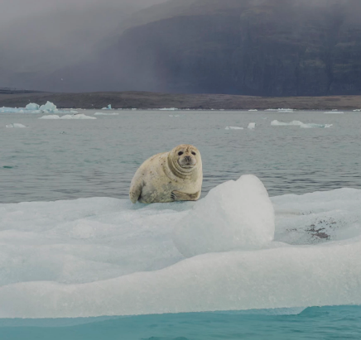
Challenge 3
This photograph of a ringed seal was captured moments before a polar bear launched an attack. Write a detailed description of the attack - before, during and after. Include sentences that require possessive apostrophes for both singular and plural nouns.

