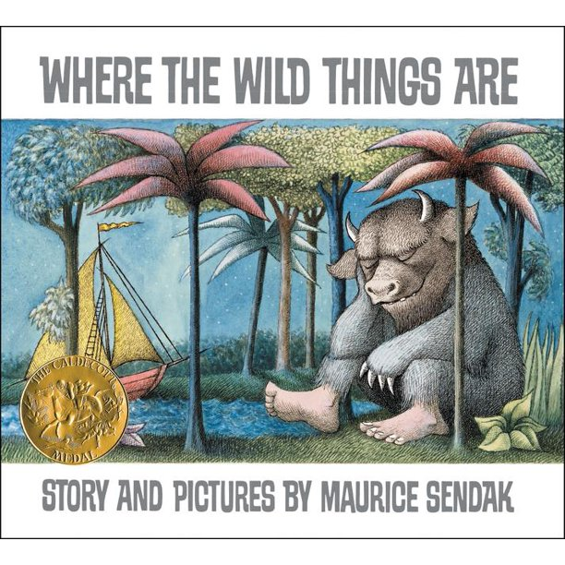
This is the new book we will be looking at this term. Here is the front cover. What do you think the book might be about? Where do you think the story is set? What do you think will happen in the story? What type of story do you think it is – sad, funny, exciting, or scary? Type your answers below or write them down on some paper and send me your work. I’m excited to read your ideas.

