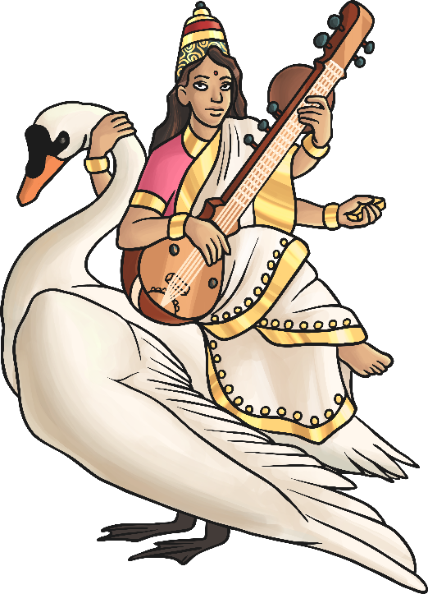
Saraswati

Saraswati is the goddess of knowledge and the arts.
She has 4 arms and rides a swan, which represents pure knowledge. She is sometimes seen with a peacock which is to represent the arts.
She dresses in a white dress with glistening gold edges. She also carries with her a lute, this is to show her gift of music and performance, and she holds a small book.
I choose to pray to Saraswati to help me in my exams, especially my music exam, which is next week.

