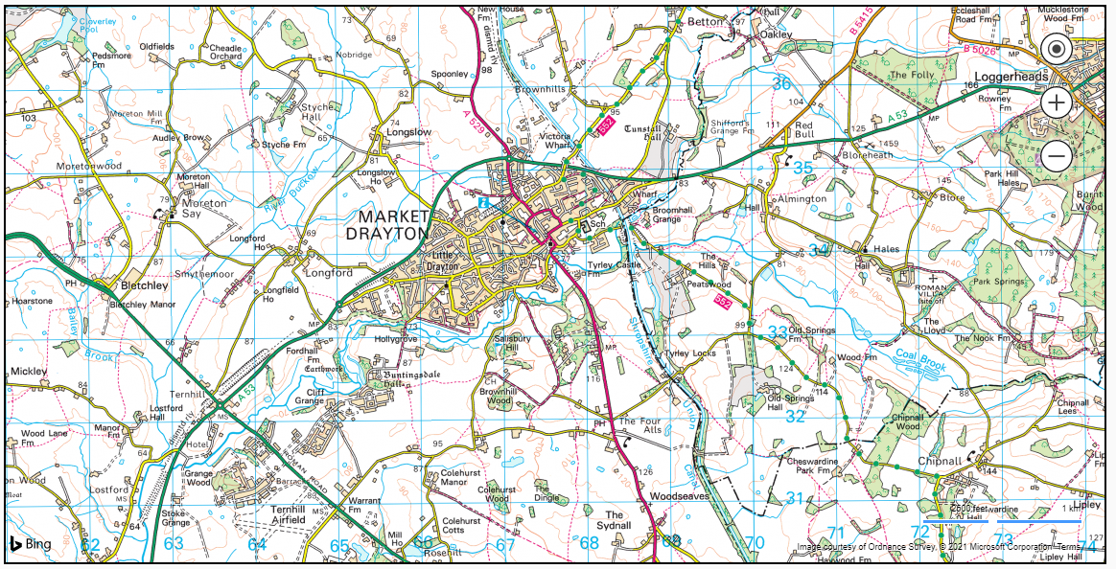
On the map, can you label 3 physical feature and 3 human features? Can you add them under two headings?

Extension: Can you think of one human feature and one physical feature of Shropshire? Can you find out three facts about each?

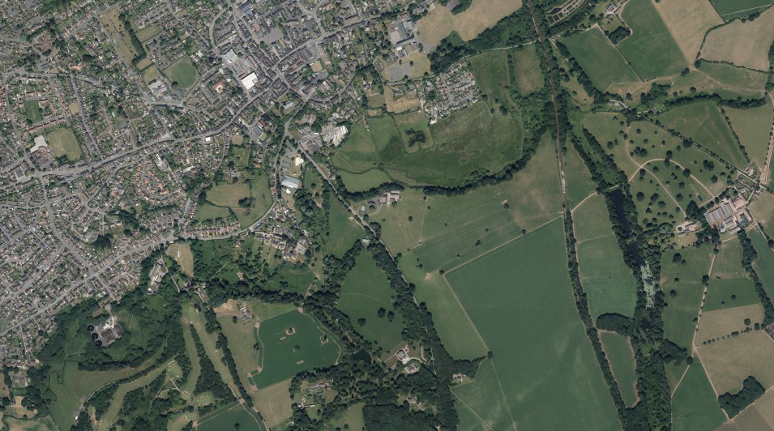
Can you label this photograph with three human and three physical features?

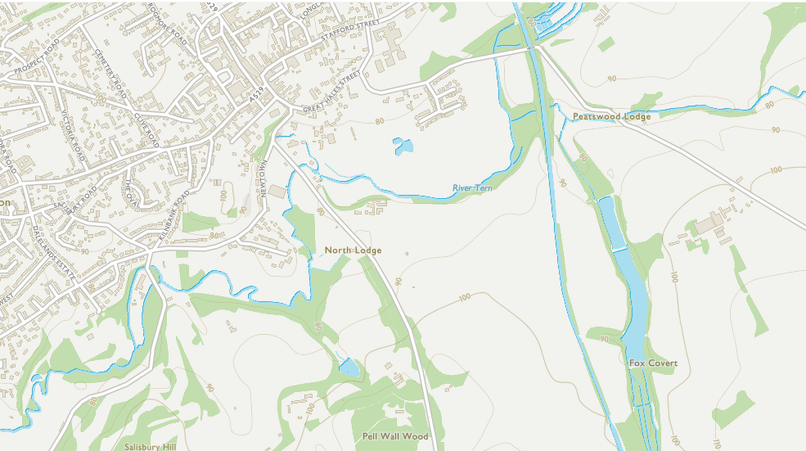

This is a map of the area above to help you.

