Learning Objective
We are learning how to write effective expanded noun phrases.

Challenge 1
Read the passage below. It has lots of simple noun phrases. Expand the simple noun phrases by adding an adjective from the list in the spaces provided.

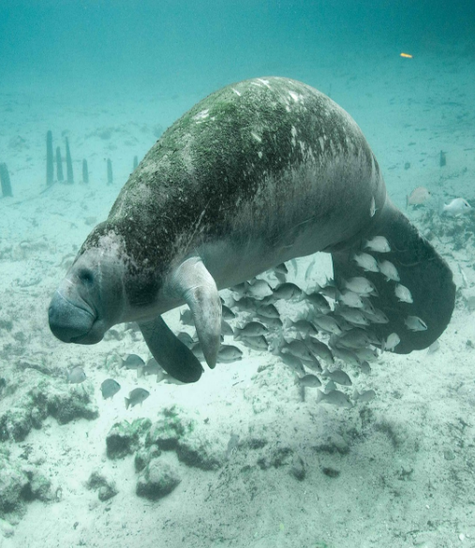
All of sudden, I heard a deep exhale of breath. I turned around and right behind my kayak was a manatee. I could see its ___________ tail moving up and down just beneath the surface of the _________ water. Sadly, it had a badly _________ body, which must have been caused by the __________ propeller blades of a motorboat. In the __________ water I was able to see how it used its _________ upper lip to rip up grass that was growing from the riverbed. I was so thrilled to be sharing this part of the river with this ________ giant. My trip to Florida, which is nicknamed the ________ State, will be etched into my memory forever.
Adjective
List

knife-like
gentle

sunshine
scarred

crystal-clear
powerful

shallow
paddle-shaped

Challenge 2
Use an adjective (before the underlined noun) and a prepositional phrases (after the underlined noun) to make each simple noun phrase in the sentences below more descriptive. Start your prepositional phrases with one of the following prepositions:
with
on

at
in

1) In the narrow river channel, the manatees faced daily danger.
e.g. In the narrow river channel, the roly-poly manatees with inquisitive natures face daily danger.
2) Near the hot springs, the manatees were gliding through the shallow water.
3) As the river narrowed, the motorboat collided with the slow-moving manatee.
4) The tourist was getting ready to film the aggregation of manatees.
5) The snorkeller could see the manatees feeding on the floating vegetation.

Challenge 3
Imagine that you were one of the snorkelers that we saw in the film clip. Despite not being allowed to touch the manatees, a young inquisitive calf decided to take a liking to you and, using her flippers, pulls you in towards her for a cuddle! (This writing idea has been taken from a real-life encounter!) Write about this remarkable encounter using lots of effective expanded noun phrases that use both adjectives and prepositional phrases to build description.

