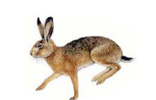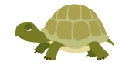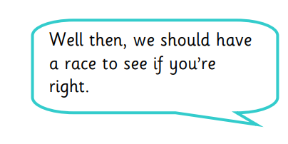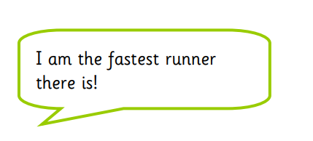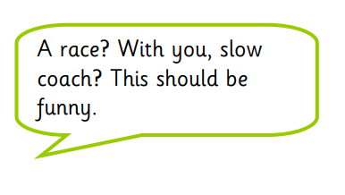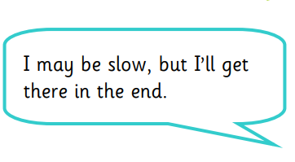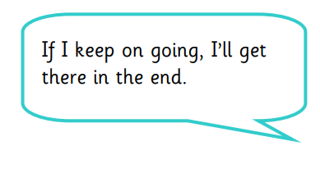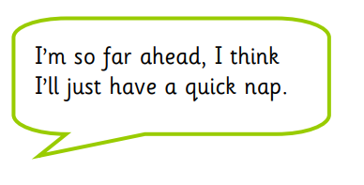

Hurrah, I’m the winner!

How embarrassing. Beaten by a tortoise!

Look at these speech bubbles. They represent what the characters in ‘The Hare and the Tortoise’ might say. Can you retell the story using actions, descriptions and speech? Include the speech in the bubbles as part of the story. Remember to use the correct speech punctuation including capital letters, inverted commas as well as other punctuation marks.. You will have to decide who said each one. Try to think of an exciting speech verb other than ‘said’.