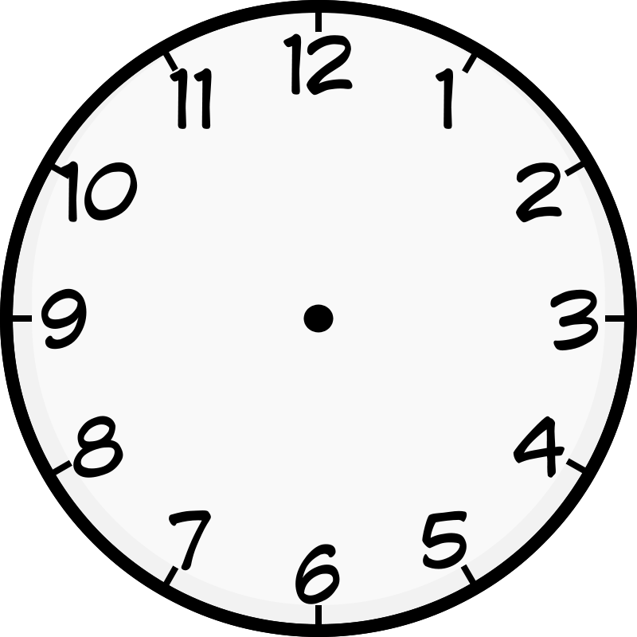
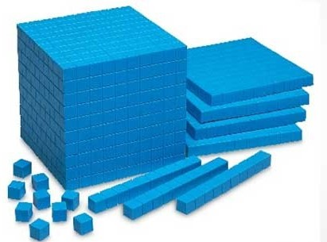
Number of the Day Warm-Up

Even
Write the number in

Expanded Form (partition)
or
Odd
4683

How much money is being shown?
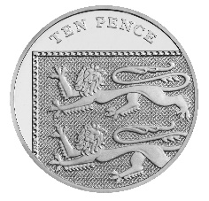
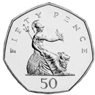
10 more

10 less
100 more
100 less

How many 1000s, 100s, 10s, and 1s are in the number of
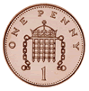
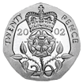
the day? Draw your answer using base-ten blocks.

Thousands | Hundreds | Tens | Ones

thousands, hundreds, tens, ones
What
time is shown?

Standards: 2OAC3; 2NBT1A1, A3, B8; 2MDC7

