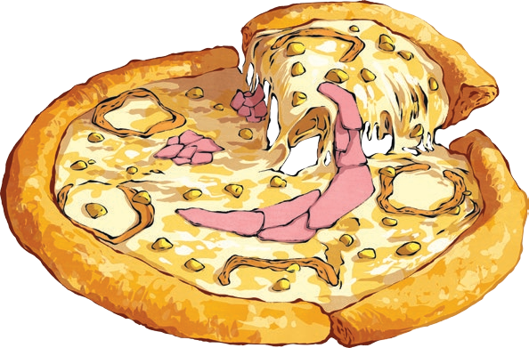
You are about to create your own ‘Awesome Pizza’. Survey your friends and see what their favourite toppings are, then interpret the data once your survey is complete.
- Choose four popular pizza toppings.
- Write your four topping choices in the tally chart below. You will see that one option, ’other’, has already been inserted for you.
- Choose a sample of people to survey.
- Complete your survey.

Tally Chart

Other

Interpreting the Data
- What was the most popular pizza topping choice?

- What was the least popular pizza topping choice?

- What is the difference between the number of children who chose the most popular pizza
topping and the least popular topping?

Pictogram
I can present and interpret data using pictograms and tables.
Choose an image to represent each child who voted, write your choices along the bottom and complete the pictogram.

Other

0 1 2 3 4 5
6 7 8
9 10
11 12 13
14 15
16 17
18 19 20

Number of Children
Pizza Toppings

