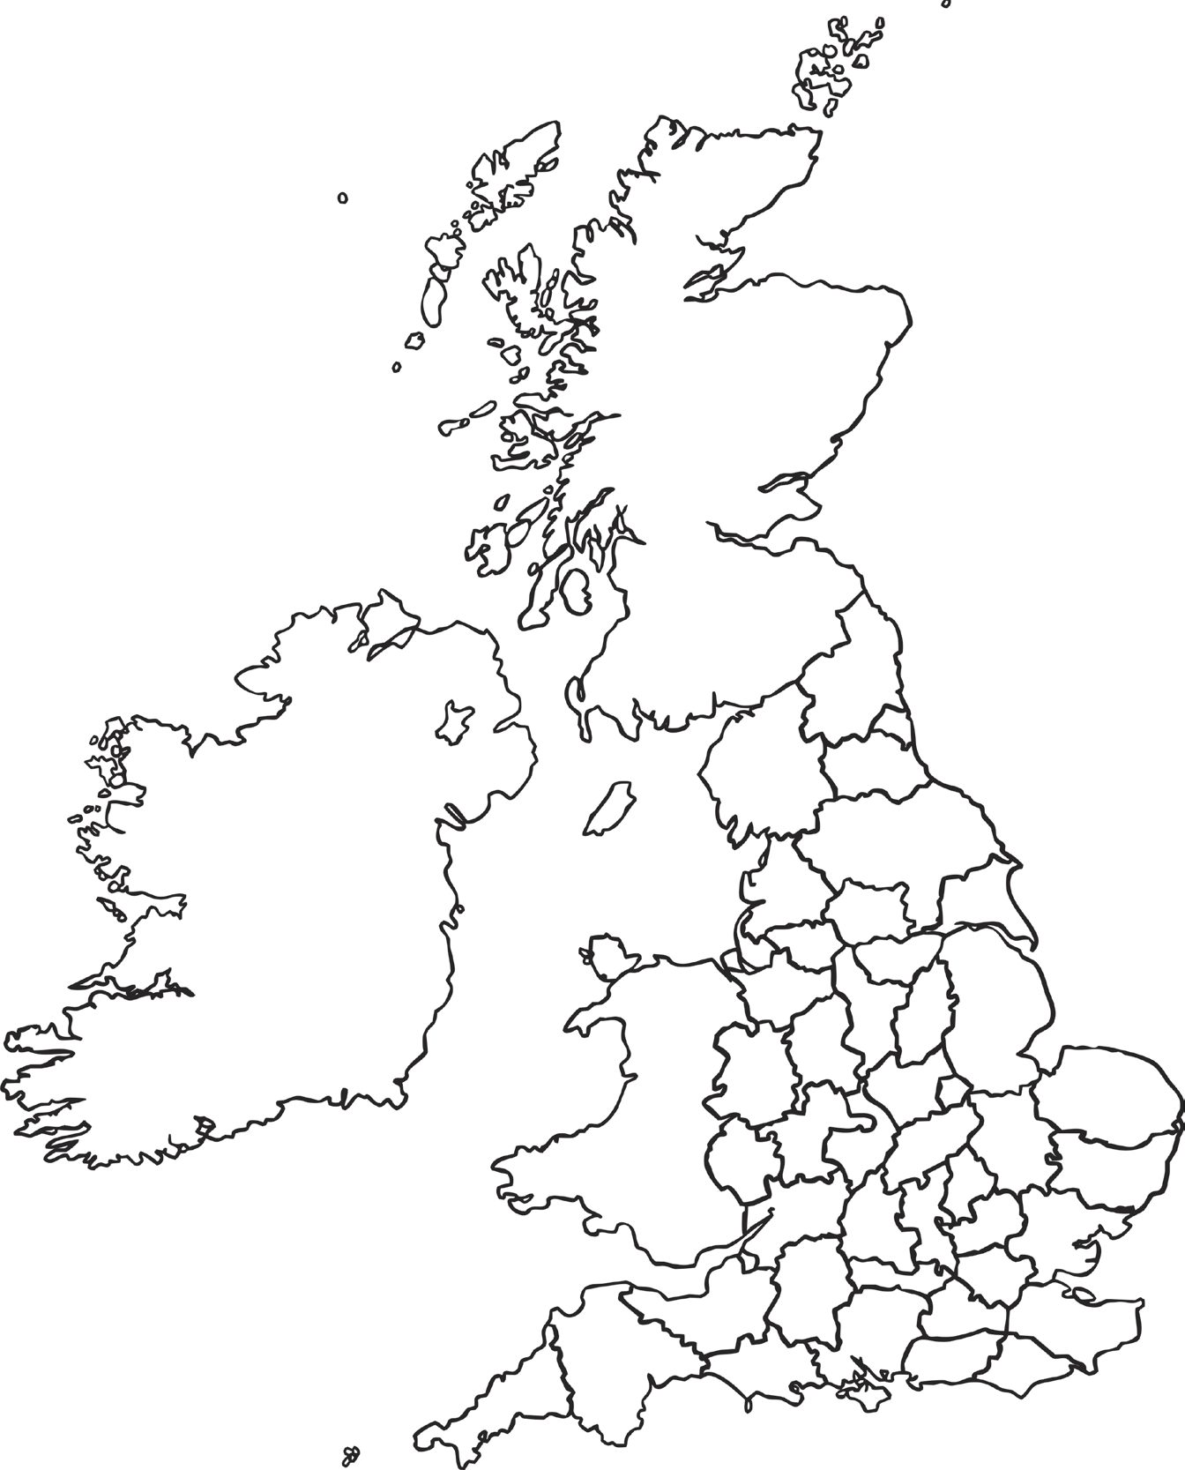
Shade in your county on the map below. Can you label the neighboring counties? How many other counties can you label?

