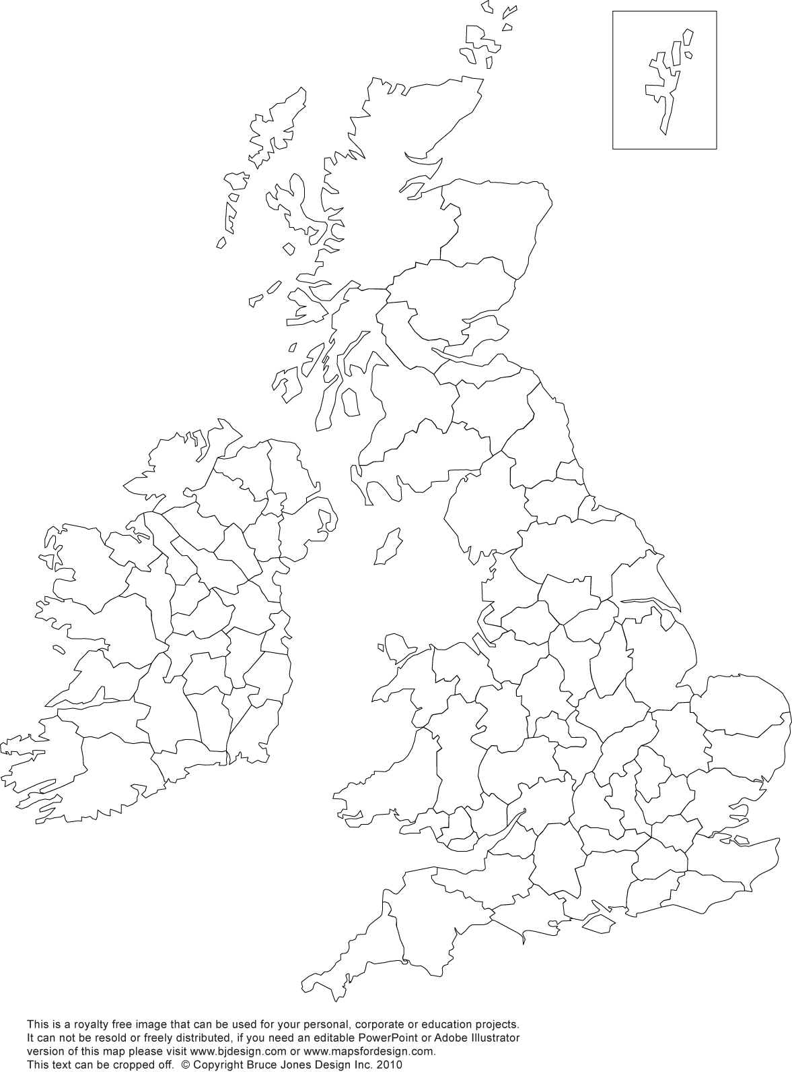

Draw in the borders of England, Scotland, Wales and Northern Ireland.

Label as many **English** counties as possible!

There is a list at the bottom to help you.

Label where you think the following towns and cities are:

* Northwich
* Manchester
* Liverpool
* London
* Birmingham
* Cardiff
* Edinburgh
* Dublin

Bedfordshire • Berkshire • Buckinghamshire • Cambridgeshire • Cheshire • Cornwall • Cumbria • Derbyshire • Devon • Dorset • Durham • East Sussex • Essex • Gloucestershire • Greater Manchester • Hampshire • Herefordshire • Hertfordshire • Isle of Wight • Kent • Lancashire • Leicestershire • Lincolnshire • Merseyside • Norfolk • North Yorkshire • Northamptonshire • Northumberland • Nottinghamshire • Oxfordshire • Rutland • Shropshire • Somerset • South Yorkshire • Staffordshire • Suffolk • Surrey • Tyne and Wear • Warwickshire • West Midlands • West Sussex • West Yorkshire • Wiltshire • Worcestershire

Find the following isles:

* Anglesey
* Isle of Man
* Isle of Wight
* Shetland Isles