Learning Objective
We are learning how to write sentences that include modal verbs and adverbs to show degrees of possibility.

Challenge 1
Highlight the modal verb in each of the following sentences. Put them in order from the most likely to happen to the least likely to happen. (The first has been done for you.)
Arctic wolves must be able to tolerate extremely cold temperatures.
Arctic wolves might occasionally live alone.
Arctic wolves can live for up to 20 years in captivity.
Arctic wolves should hunt in packs in order to be successful predators.
Arctic wolves will usually live for up to 7 years in the wild.

Challenge 2
Complete the following paragraph by filling in the gaps with appropriate modal verbs and modal adverbs.
Modal verbs include can, could, might, must, would, should, ought to, may, shall, will
(Remember that many modal verbs can also be used in their negative form.)
Modal adverbs include usually, probably, possibly, always, occasionally, surely, always, generally, often, never, certainly, perhaps, definitely.

Arctic wolves __________________ be found in extremely cold climates in Canada, Greenland and Alaska. As well as the low temperatures, these fascinating creatures ________________ tolerate long months of darkness. They ________________ live in packs of 5 to 7 members although __________________ live alone. Being carnivorous, they _______________ hunt together in order to be able to kill large prey as a grown Arctic wolf ____________ consume over 10kg of meat per meal. In the wild, Arctic wolves ____________ live up to 10 years although, in captivity, they _______________ live for up to 20 years.

Challenge 3
Write your own short article for a magazine or webpage, introducing the Arctic wolf to readers who have never heard about it before.
Try to include as many modal verbs, modal adverbs and descriptive words from the Word Wall.

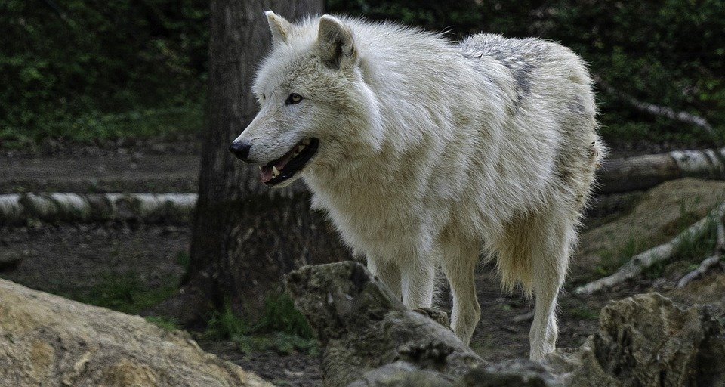
Word Wall

shall
must
will
might
could
can
curious
untamed
protective
wild
timid
carnivorous
perhaps
possibly
often
snow wolf
usually
would

