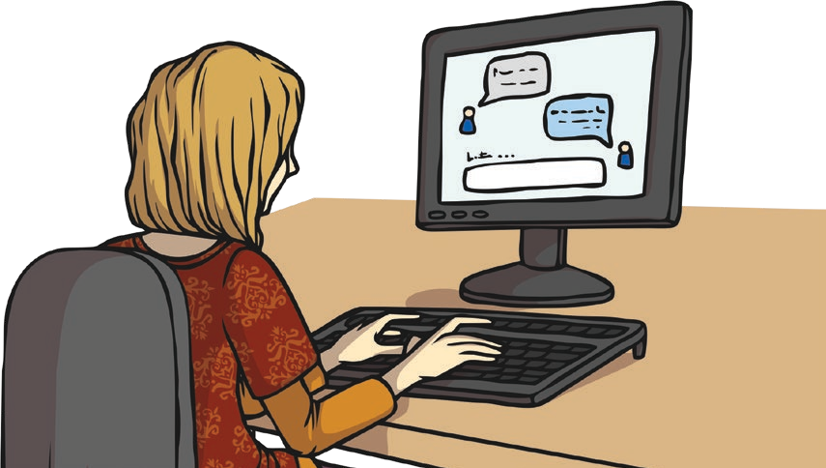
Safer Internet Day 2021

What is Safer Internet Day all About?
Safer Internet Day started in 2005 and now happens in over 100 countries around the world. It aims to help young people to use the Internet safely and make good choices online. This year, it is happening on Tuesday 9th February and the theme is ‘An Internet we trust:
exploring reliability in the online world’.

An Internet We Trust: Exploring Reliability in the
Online World - What Does the Safer Internet Day 2021 Theme Mean?
The Internet is a great place to chat to friends and find out interesting and fun stuff. But how do we know the difference between what is fact and fiction?

Some Uses of the Internet:
- gaming
- shopping
- learning new things
- reading about famous people
- booking tickets
- chatting to friends

Although the Internet is a great source of information for young people, unfortunately, not everything is always as it seems. The online world also contains fake news and misleading content, which can affect young people’s decisions, views and opinions.
What Is Fake News?
Fake news is false information that claims to be true and reliable news.

Is it true?
Safer Internet Day
The 2021 Safer Internet Day theme focuses on supporting young people to be able to decide what they can trust online. It aims to help them to feel more comfortable at separating fact from fiction and to develop skills to be able to make the best decisions while online.

How Is Fake News Harmful?
Fake news is harmful because it:
- affects our views;
- breaks the trust we have of all people in the media, even though many are reporting honestly;
- causes people to act on false information.
How to Spot Fake News Being able to spot whether content is fact or fiction
is difficult and something that even adults can find tricky. Here is a guide to help you spot fake news.
- Who is reporting the story? Check that a trustworthy news channel is reporting the story, such as the BBC.
- Is there an author or journalist name? If not, it could be suspicious.
- What is the domain name? Fake news stories will often have a strange domain name. Websites ending in .com.co are often fake versions of real sites.
- Does it seem professional? Bad web design, as well as poor spelling, punctuation and grammar, might mean it’s fake news.
- Don’t just believe the first thing you read is true; read stories from different places to get a range of viewpoints.

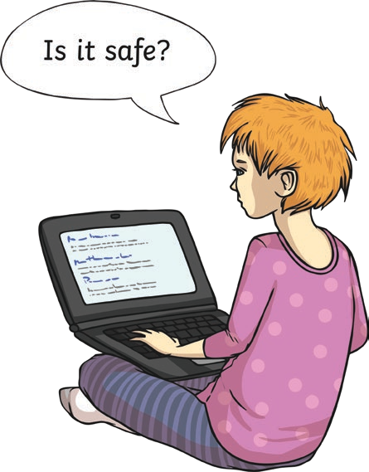
journalist - A person who writes news for newspapers, magazines or news websites.

Safer Internet Day
Questions
- When is Safer Internet Day celebrated this year? Tick one.
Tuesday 10th February Thursday 9th February Tuesday 9th February Tuesday 19th February
- Mark whether the statements about Safer Internet Day are true or false.

 | True | False
Safer Internet Day started in 2006.
It happens in over 100 countries around the world.
It aims to help young people to use the Internet safely and make good choices online.

- What is the theme for Safer Internet Day 2021? Tick one.
an Internet we trust: exploring reliability in the online world be safe on the Internet
an Internet we use: finding facts online fake news is bad
- Explain in your own words how the theme of Safer Internet Day 2021 aims to help young people online.

- What is fake news? Fill in the missing words.
Fake news is information that claims to be true and
news.
- Find and copy one word that means the same as ‘honest and reliable’.

Safer Internet Day
- How can you spot fake news? Tick two.
If there is an author or journalist name, it could be suspicious.
Poor web design, spelling, punctuation and grammar might mean it’s fake news. If there is not an author or journalist name, it could be suspicious.
If the article is older than one year.

Answers
- When is Safer Internet Day celebrated this year? Tick one.
Tuesday 10th February Thursday 9th February Tuesday 9th February Tuesday 19th February

Safer Internet Day

- Mark whether the statements about Safer Internet Day are true or false.

 | True | False
Safer Internet Day started in 2006.
It happens in over 100 countries around the world.
It aims to help young people to use the Internet safely and make good choices online.

- What is the theme for Safer Internet Day 2021? Tick one.

an Internet we trust: exploring reliability in the online world
be safe on the Internet
an Internet we use: finding facts online fake news is bad
- Explain in your own words how the theme of Safer Internet Day 2021 aims to help young people online.
Pupils’ own responses, such as: The 2021 Safer Internet Day theme, ‘an Internet we trust: exploring reliability in the online world’ aims to help young people to develop the skills to recognise what is real and what is fake online and what to do if they find misleading content.
- What is fake news? Fill in the missing words.

Fake news is false information that claims to be true and reliable news.
- Find and copy one word that means the same as ‘honest and reliable’.

trustworthy

- How can you spot fake news? Tick two.
If there is an author or journalist name, it could be suspicious.

Poor web design, spelling, punctuation and grammar might mean it’s fake news. If there is not an author or journalist name, it could be suspicious.
If the article is older than one year

