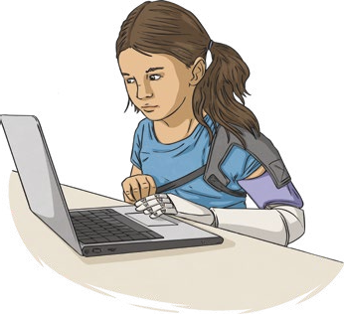
Safer Internet Day 2021
Every year, schools across the world support Safer Internet Day, an event which started in 2005. The aim of the day is to raise awareness about current online issues and to help young people learn about how to be safe and sensible online. This
year’s event is being held on Tuesday 9th February.
Each year, Safer Internet Day has a different, themed
focus. The theme for 2021 is, ‘An Internet we trust:
exploring reliability in the online world’, which highlights the importance of questioning the reliability of
what we see online by asking, what is factual information and what might be fiction?

An Internet We Trust: Exploring Reliability in the Online World
The online world is a great source of information and offers opportunities to research, learn new facts or skills and even broaden viewpoints for people of all ages. The Internet is also a great way for young people to experience positive relationships with their peers, such as through gaming and social media sites. However, as they navigate around the online world, they are constantly having to make decisions about who and what to trust.
The 2021 Safer Internet Day campaign focuses on how to decide what we can trust on the Internet, supporting young people to question, challenge and improve the online world. It hopes to give young people the skills and strategies to make smart decisions while online and to be able to spot and speak out against any harmful and misleading content they might come across.

Uses of the Internet
We all use the Internet differently. Here are some online activities that people enjoy:
  - listening to music
  - using apps to keep in touch with family who live far away
  - watching funny videos
  - chatting with friends
  - gaming
  - researching for homework How do you like to use the Internet?

Page 1 of 3
visit twinkl.com

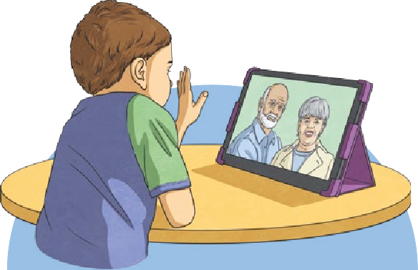

Everything Is Not Always as It Seems
Photos
Photos can often embellish (exaggerate) real life. People usually use the prettiest, happiest pictures of themselves to share online. Images of other people’s (carefully chosen) so-called, perfect lives can sometimes leave you feeling low. Try
not to compare yourself; remember that these photos probably don’t tell the whole story.
Fake News
Although the Internet is a great source of information for young people, we should not always believe everything we read. Unfortunately, the online world also contains misleading content and fake news. Fake news is false information that is published, claiming to be true and reliable news.
Bogus and fictitious information can be incredibly harmful as
it can influence and persuade our decisions, actions, views and opinions, as well as what we share online. It also breaks the trust we have of people in the media, many of whom are in fact reporting honestly.
Safer Internet Day 2021 will look at why inaccurate content exists, where it
comes from and how young people can manage it.
Reducing Screen Time
If you find yourself spending a lot of time online and even thinking about it when you’re offline, then you probably need to reduce your screen time. While the Internet can be fun, there’s a whole world out there, waiting to be explored. Make sure you take regular breaks away from electronic devices.
Did You Know…?
Globally, over 4.6 billion people are regular Internet users according to a study from October 2020. This encompasses approximately 59% of the global population.

Page 2 of 3
visit twinkl.com

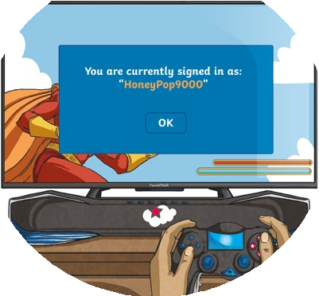
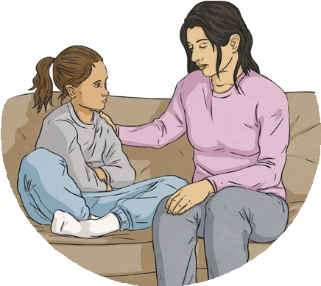

Staying Safe Online
The Internet is an incredibly powerful tool that can be accessed at all times through devices at our fingertips. However, it is crucial to consider how, when and why we use it. Staying safe online is very important for our health and wellbeing. We also need to be supporting others online, just as we would help and support our friends and family offline.
Sometimes, if we are in a group chat or playing an online game, we might see or hear something that worries, confuses or upsets us. If this happens, there are ways to report it so that it is less likely to happen again. For example, many apps and games have ‘Report’, ‘Help’ or ‘Block’ buttons. ‘Report’ can help us to report anything that makes us feel unsafe or unhappy. ‘Help’ is if you have a problem with an app and ‘Block’ is useful if you don’t want to get any more messages from someone. It can also be a good idea to save evidence (such as a picture or a message).
Most importantly, we should tell an adult about what has happened and how it has made us feel.

Safer Internet Day 2021 celebrates the amazing range of information and opportunities online. The Internet has potential to inform and connect young people but they must remember to be safe, sensible and know how to be able to separate fact from fiction.

Page 3 of 3
visit twinkl.com

Questions
- What is the theme of Safer Internet Day 2021?

- Which of the following is the 2021 Safer Internet Day theme focusing on? Tick two.

questioning the reliability of what we see online researching homework
to give young people the skills and strategies to make smart decisions while online making inaccurate content

- Find and copy a word that means the same as ‘find their way’.
- Fill in the missing words.

Although the Internet is a great source of information for young people, we should not always everything we read. Unfortunately, the online world also contains
content and fake news.

- Describe what fake news is in your own words.

- In what way can the Internet help families that live in different countries?

Page 1 of 2
visit twinkl.com

- Click on the correct action to take to match the situations.
Sid tries but he can’t log on to his game.
Select

A stranger keeps sending Luca annoying messages.
Select

Abdulrahman saw a video that worried him.
Select

Something has made you feel unsafe, worried or unhappy.
Select

- Nisha is worried about an unkind comment that someone made on her latest video. Someone tells her to ‘forget about it’ but she is still worried. Do you think this advice is helpful? What could she do instead? Support your answer with evidence from the text.

- Do you think Safer Internet Day is important? Explain your answer.

Page 2 of 2
visit twinkl.com

