Learning Objective
We are learning how to write sentences about lions that use brackets, commas and dashes to indicate parenthesis.

Challenge 1
Read each sentence and place the parenthesis (additional piece of information) inside either a pair of brackets, dashes or commas.
- African lions renowned for enjoying each other’s company are the only members of the cat family that live and hunt together.
- Lions usually the females of the pride often work together when attempting to bring down larger herbivores such as wildebeest and buffalo.
- The male lion’s roar which could be heard five miles away signalled to the approaching pride that they must not enter his territory.
- The cubs which were too young to take part in the hunt were the last members of the pride to feed on the slain zebra.
- The marsh lions a group that preferred to hunt when the moon was below the horizon were drawn to the racket of the hyenas.

Challenge 2
In your Literacy book, rewrite each of the following sentences by adding a parenthesis (additional piece of information) after the word that has been highlighted in bold. Try to use a range of parenthesis punctuation marks: brackets, dashes and commas.

- The angry buffalo lowered its head and charged at the lion.
- As the lion started to close in on the distressed buffalo calf, its mother came to the rescue.
- The pride did not come to the aid of the elderly, injured male.
- The brave warthog refused to be beaten by the lioness.
- The farmers were convinced that the lions were responsible for killing their cattle.

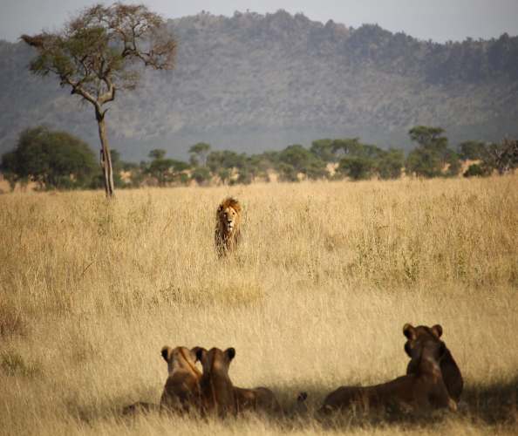
Challenge 3
The King Returns
Under this title, write descriptively about what you see in the photograph. Within some of your sentences, include a parenthesis. Try to experiment with the full range of parenthesis punctuation.

