Mrs Tomkinson’s Quiz
Rocks and soils

- Troy and Cooper discuss which of the rocks in their rock collection they think are the hardest. They decide to carry out the scratch test.

This table shows their results:

Rock | Was scratched by …
 | fingernail | nail | matchstick | plastic knife
Coal | No | Yes | No | Yes
Limestone | No | Yes | No | No
Granite | No | No | No | No
Chalk | Yes | Yes | Yes | Yes

- Which rock could Troy’s fingernail scratch?

- Which rock was the hardest? How do you know?

- Use the table to answer the following question.
Write the name of each rock in the boxes below. Place them in order from softest to hardest.

Softest Rock Hardest Rock

- Write down two things that hard rocks could be used for:

and

© Sigma Science SGM3DA01 – Rocks and soils p1 www.sigmascience.co.uk
- Mary Anning was an expert fossil hunter, what is the correct word for her job studying fossils?

- What is the only type of rock where you can find fossils?

- Brick is not a natural rock, what type of rock is it?

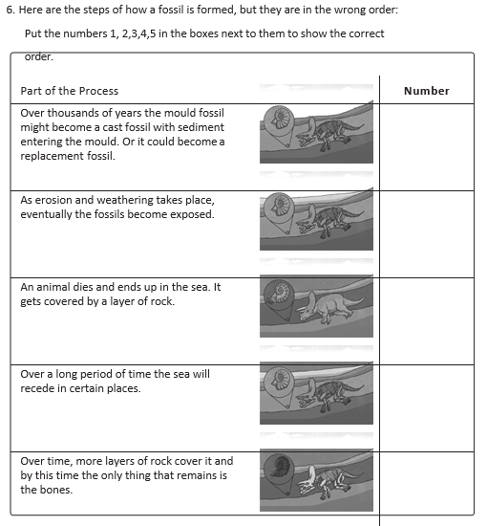
© Sigma Science SGM3DA01 – Rocks and soils p2 www.sigmascience.co.uk

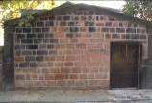
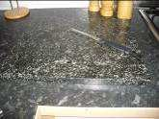
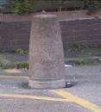
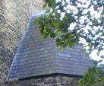
- There are three types of natural rock. Join up each rock to the correct rock type:

Rock | Rock Type
Sandstone | Igneous
Marble | Sedimentary
Granite | Metamorphic

8.

© Sigma Science SGM3DA01
Rock Natural or artificial Job
Why selected
Rock Natural or artificial Job
Why selected
Rock Natural or artificial Job
Why selected
Rock Natural or artificial Job
Why selected
www.sigmascience.co.uk

