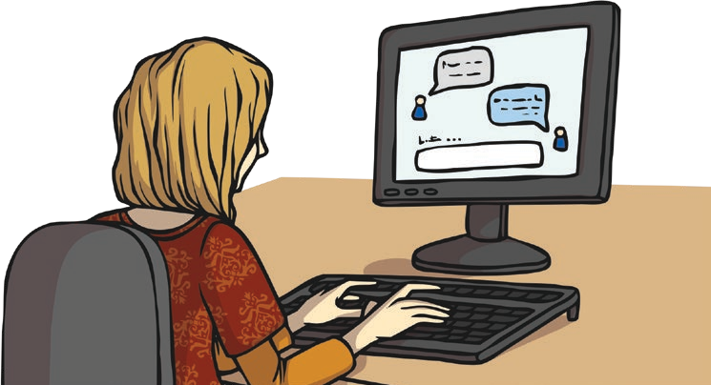
Safer Internet Day 2021
Safer Internet day started in 2005 and now happens in over 100 countries worldwide, every February. It aims to help young people to keep themselves safe online by making responsible choices. This year, it is being held on Tuesday 9th February and the theme is ‘An Internet we trust: exploring reliability in the online world’.

Some Uses of the Internet:
- watching videos
- listening to music
- video chatting with family members or friends
- learning new skills
- shopping
- gaming
- finding out about the news, weather and sport’

An Internet We Trust: Exploring Reliability in the Online World - What Does the Safer Internet Day 2021 Theme Mean?
The Internet has many uses and is a great source of information. It offers opportunities to research, learn new facts or skills and it can help to broaden viewpoints. Many young people spend a lot of their time online so it is important that they know how to be safe, sensible and smart, while also being able to enjoy everything it has to offer.
The 2021 Safer Internet Day theme focuses on being able to decide what we can
trust online. It supports young people to question and challenge what they
see and read on the Internet.

Safer Internet Day

Although the Internet is a great source of information for young people, unfortunately, not everything is always as it seems. The online world also contains fake news and misleading content, which can impact young people’s decisions, views and opinions. It can also impact what they share online.
What Is Fake News? Fake news is false information that is
published, claiming to be
true and reliable news.
The day will also look at the emotional impact that misleading content can have on young people and why it is important to create a supportive,
critical and questioning environment online. It aims to encourage debate and discussion. The day aims to give young people the skills to support one another and the strategies to spot and speak out against harmful and misleading
content online.

Is it true?

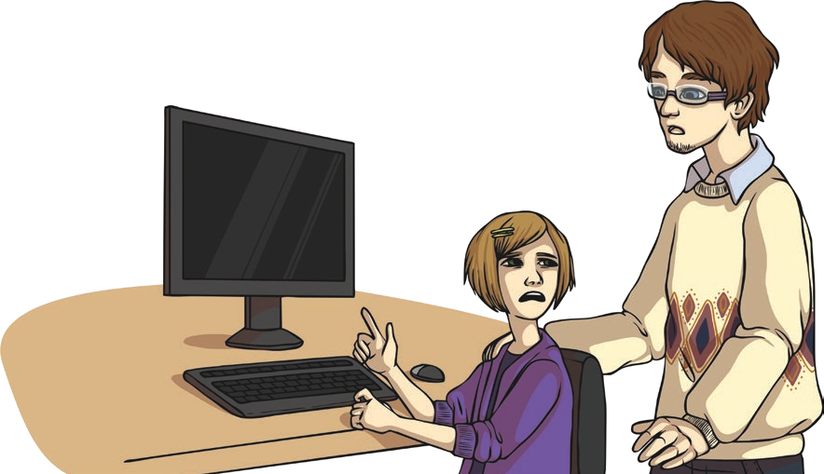
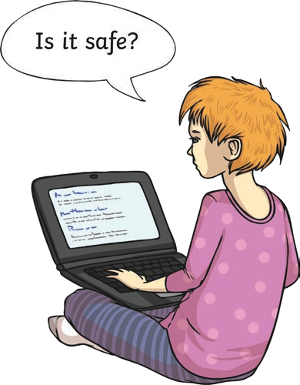
Separating Fact from Fiction
Being able to distinguish whether content is fact or fiction can be a difficult task that even adults can find tricky. Safer Internet Day aims to help young people to recognise inaccurate content and develop the skills they need to be able to make the best decisions while online.
Once they are aware of and ready to separate fact from fiction, they must take the next steps in helping to create an Internet that is full of trustworthy and reliable information.
make the right choices so that everyone can stay ‘together for a safer internet’.

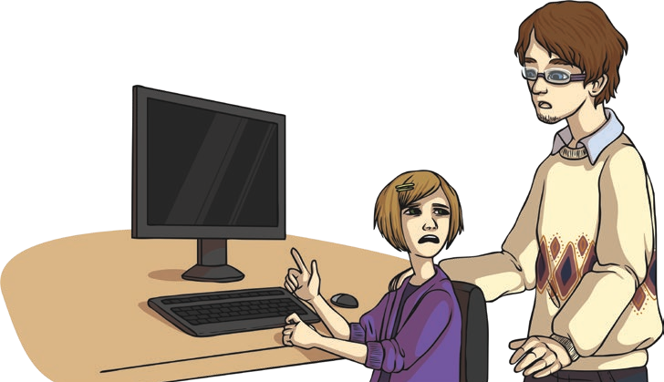
Safer Internet Day
Photos
Keep in mind that photos can often exaggerate real life. People usually use the prettiest, happiest pictures of themselves to share online. Images of other people’s (carefully chosen) so-called, perfect lives can leave you feeling low. Try not to compare yourself, as they don’t always tell the whole story.

How Is Fake News Harmful?
Fake news is harmful because it:
  - affects our views;
  - breaks the trust we have in people in the media, many of whom are in fact reporting honestly;
  - causes people to act on false information.
How to Spot Fake News
Here is a guide to help you recognise fake news.

- Who is reporting the story? Check that a trustworthy news outlet is reporting the story, such as the BBC.
- Is there an author or journalist name? If not, it could be suspicious.
- What is the domain name? Fake news stories will often have a strange domain name. Websites ending in .com.co are often fake versions of real sites.
- Does it seem professional? Bad web design, as well as poor spelling, punctuation and grammar, might mean it’s fake news.
- Don’t just assume the first thing you read is true; read stories from different sources to get a range of viewpoints.

Safer Internet Day
Questions
- How often is Safer Internet Day celebrated? Tick one. twice a year
every month once a year
every January

- Look at the Some Uses of the Internet section. List three different ways people use the Internet.
1.
2.
3.
- Fill in the missing words. The online world also contains news and misleading content, which can young people’s decisions, views and opinions.
- Explain in your own words what the theme for Safer Internet Day 2021 is about.

- Look at the Separating Fact from Fiction section.
Find and copy one word that means the same as ‘differentiate’.

Try not to compare yourself, though, as photos don’t always tell the whole story.
What do you think this means?

Safer Internet Day
- Draw four lines to complete each sentence.

Check that a trustworthy news outlet… |  | a strange domain name.
Fake news stories will often have… |  | is reporting the story, such  as the BBC.
Bad web design, as well as… |  | to get a range of viewpoints.
Read stories from different sources... |  | poor spelling, punctuation and grammar, might mean  it’s fake news.

- Why do you think we have Safer Internet Day and do you think it is important?

Safer Internet Day
Answers
- How often is Safer Internet Day celebrated? Tick one. twice a year
every month

once a year
every January

- Look at the Some Uses of the Internet section. List three different ways people use the Internet.

Accept any three of the following: watching videos, listening to music, video chatting with family members or friends, learning new skills, shopping, gaming, finding out about news, weather and sport.

- Fill in the missing words.
The online world also contains fake news and misleading content, which can impact
young people’s decisions, views and opinions.
- Explain in your own words what the theme for Safer Internet Day 2021 is about.

Pupils’ own responses, such as: The 2021 Safer Internet Day theme, ‘an Internet we trust: exploring reliability in the online world’ is about helping young people to develop the skills to question what they read online, know how to recognise what is real and what is fake and what to do if they find misleading content.

- Look at the Separating Fact from Fiction section.
Find and copy one word that means the same as ‘differentiate’.

distinguish
- Try not to compare yourself, though, as photos don’t always tell the whole story.
What do you think this means?

Pupils’ own responses, such as: Photos that people share online are often very carefully chosen to try to show a perfect and happy life but they do not show the more negative aspects of these people’s lives, which means that they are not telling the whole story.

Safer Internet Day
- Draw four lines to complete each sentence.

Check that a trustworthy news outlet… |  | a strange domain name.
Fake news stories will often have… |  | is reporting the story, such  as the BBC.
Bad web design, as well as… |  | to get a range of viewpoints.
Read stories from different sources... |  | poor spelling, punctuation and grammar, might mean  it’s fake news.

- Why do you think we have Safer Internet Day?

Pupils’ own responses, such as: I think we have Safer Internet Day so that young people are more aware of the risks involved in being online and how to behave in a safe and sensible way while also being able to enjoy everything the Internet has to offer.

