Aldi’s Christmas Advert 2021
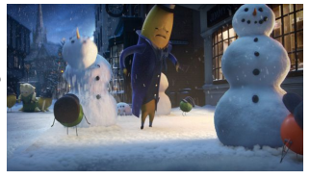

Make some notes on what you see in the advert as you watch it.
_____________________________ _____________________________
_____________________________ _____________________________
_____________________________ _____________________________
_____________________________ _____________________________
What is the main idea of this advert? _________________________________________________________________
_________________________________________________________________
_________________________________________________________________
_________________________________________________________________
Who are the characters in the advert?
_____________________________ _____________________________
_____________________________ _____________________________
_____________________________ _____________________________
Do you like this advert? Give your reasons for your answer. _________________________________________________________________
_________________________________________________________________
_________________________________________________________________
What are your thoughts on the music used? _________________________________________________________________
_________________________________________________________________

Stop the video at 21 seconds
Why does Ebanana hate Christmas?
___________________________________________________________________________________
___________________________________________________________________________________
___________________________________________________________________________________ Stop the video at 25 seconds
Write 4 adjectives to describe Ebanana Scrouge.

- _____________________________
- _____________________________
- _____________________________
- _____________________________

Stop the video at 36 seconds
Who is Marcus Radishford representing and why do you think he has a role in this year’s Christmas advert for Aldi?
___________________________________________________________________________________
___________________________________________________________________________________
- ___________________________________________________________________________________

Stop the video at 1 minutes 19 seconds
Do you know what famous Christmas story this advert is recreating?
___________________________________________________________________________________
___________________________________________________________________________________ Stop the video at 1 minutes 19 seconds
Write 4 different emotions you saw in this advert

_____________________________ _____________________________
_____________________________ _____________________________

