Disney’s Christmas Advert 2021
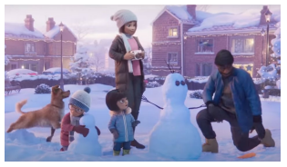
- Make some notes on what you see in the advert as you watch it.

- _____________________________
- _____________________________
- _____________________________
- _____________________________
- _____________________________
- _____________________________
- _____________________________
- _____________________________

- What is the main idea o this advert?
- ______________________________________________________________________
- ______________________________________________________________________
- ______________________________________________________________________
- ______________________________________________________________________ Who are the characters in the advert?

- __________________________________________________________
- ____________________________________________________________

- Do you like this advert? Give your reasons for your answer.
- ___________________________________________________________________
- ___________________________________________________________________
- _________________________________________________________________
- ___________________________________________________________________
- _________________________________________________________________

- Stop the video at 24 seconds How do you think the man is feeling? ______________________________________________________________________

__________________________________________________________
Why do you think he is feeling this way? ____________________________________________________________

____________________________________________________________Stop the video at 1 minute 10 seconds What do you think the relationship is between these characters? ____________________________________________________________

___________________________________________________________
Stop the video at 2 minute 17 seconds. Why is the man upset?

____________________________________________________________

_______________________ ____________________________

Stop the video at 2 minutes 54 seconds What message is being shown? ____________________________________________________________

____________________________________________________________
Stop the video at 3 minutes 10 seconds Write 4 different emotions you saw in this advert
• _____________________________
• _____________________________
• _____________________________
• _____________________________

