Homework project:

To conclude our learning from this half term, I would like you to use what you have learnt this term and create a project that involves space. This could mean building the scene of the first moon landing in a shoe box. You could papier-mâché your favourite planet. You could even create a fact file about your favourite astronaut.
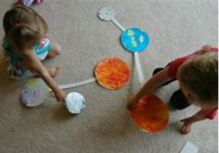
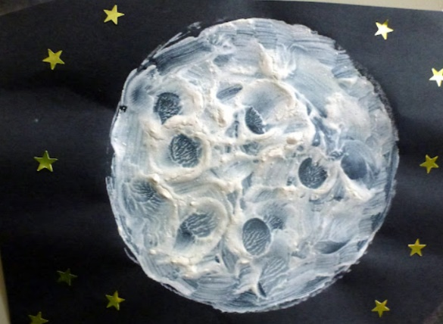
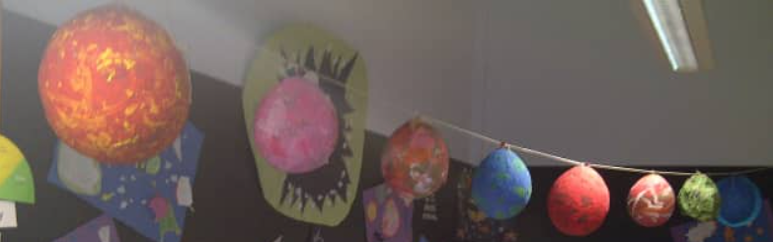
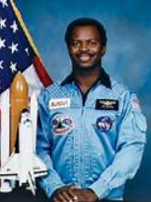
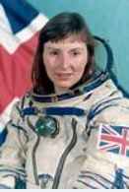
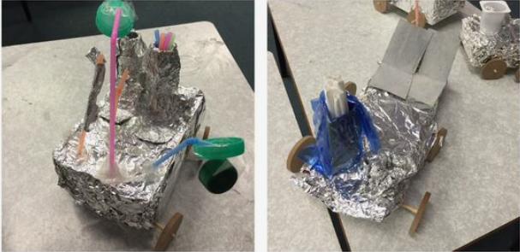
Please could you bring this back by the first Friday of next term which will be the 29th April. I look forward to seeing your wonderful projects.

