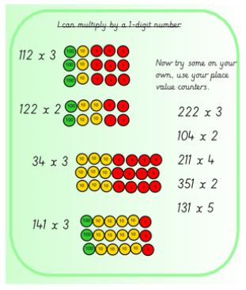

Can you write the multiplications for questions 1-4

For the questions below, draw the place value chart and complete the multiplication

Gold