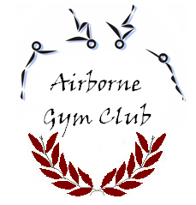
Airborne Gymnastics Club

Dear Parent,

With the support of Airborne Gymnastics Club and Cheswardine Primary School, Airborne Gymnastics Club will be running a series of after school gymnastics sessions at the School this term. The sessions are being run by British Gymnastics qualified coaches (CRB cleared) and the Gym Club is fully insured to run the sessions at the School.

The sessions for the pupils will take place from Thursday 12th January–16th February.
SIX inclusive sessions.
The sessions will run between 15:15 and 16:15 hours on a Thursday afternoon.
Each session will cost £4.00 and it is requested that payment for all sessions (£24.00) is made IN ADVANCE by cheque or cash.

Participants must wear non-baggy clothing appropriate for taking part in gymnastics sessions. School PE kit is considered suitable. Hair, if long, is to be tied back and any jewellery restricted to ear studs. If a child is not dressed in a safe and appropriate manner the coach will have the right to ask the child to either change into more appropriate clothing, or to sit out of the session.

Places are limited to 20 and will be filled on a first come first served basis. If you would like your child to participate, please email, ring or text Jason on the number below to book your child’s place.

****FOR ALL BOOKINGS PLEASE EMAIL JASON TUCKER****
airbornegymclub@yahoo.co.uk
07427 556781
When booking your child’s position can you please let me know:
Name of pupil and Class:
How you are paying for sessions: Cash or cheque
I enclose the amount of £24.00
CASH or CHEQUE: to be handed in at reception with child’s name and class on envelope

FOR ENQUIRIES ABOUT JOINING AIRBORNE GYMNASTICS PLEASE CALL: 07427556781
Name of person authorised to collect my child:……………………………………………………
Contact number …………………………………………………………
My child has the following medical conditions:
……………………………………………………………………………………………………………………………………………

